

**CLINIC BOOKING**

**Software Requirement Specification**

**– Hanoi, May 2023 –**

**Table of Contents**

**I. Overview 6**

**1. Introduction 6**

**2. System Functions 8**

**Screen Flow 8**

**Screen Details 8**

**User Authorization 12**

**Non-Screen Function 13**

**3. Common Requirements 14**

**II. Functional Requirements 14**

**1. Public Feature 14**

**a. Home Page 14**

**b. Web Blog List 15**

**c. Web Blog Details 16**

**d. Web Doctor List 17**

**e. Web Service List 18**

**20**

**2. Common Feature 21**

**a. Sign in 21**

**b. Register 22**

**C. ChangePassword 23**

**d. Forgot Password 24**

**e. User profile 25**

**3. Admin Feature 26**

**a.Settings List 26**

**b.Setting Details 27**

**c. Account List 29**

**d. Account Detail 30**

**e. DashBoard 31**

**4. Marketing Feature 25**

**a.Service List 35**

**b.Service Details 37**

**c. Service Adds 38**

**d. Blog List 39**

**d. Blog Detail 39**

**d. Blog Add 39**

**d. Blog Edit 39**

**5. Staff Feature 43**

**a.Doctors List 25**

**b.Doctor Details 27**

**c.Doctor Edit 29**

**d.Patients List 31**

**e.Patient Details 32**

**f.Patient Edit 34**

**g. Appointments List 43**

**h. Reserve a Service 45**

**i. Reservations List 46**

**6. Doctor Feature 46**

**a. My Patients 46**

**b. My Patient Details 47**

**c. My Appointments 48**

**d. My Appointment Details 49**

**e. My Feedbacks 50**

**7. Patient Feature 51**

**a. Book Appointment 51**

**b. Reserve a Service 52**

**c. Appointment History 53**

**d. Reservation History 54**

# 

# 

# 

# 

# 

# 

# 

# 

# 

# 

# 

# 

# **I. Overview**

**General information about the project:**

**● Project name: Clinic Booking**

**● Project code: CB**

**● Group name: Group 7**

**● Software type: Web Application**

## **1. Introduction**

In the current development era, many industries have applied the technology shift from traditional to digital technology to save time and effort for both users and businesses. In addition, there are still many professions that still use traditional methods, reducing the productivity and time of the system, most notably the current medical examination and treatment of hospitals. Currently, at public hospitals, people still have to wait in line for a long time when visiting the hospital. Although the current Covid-19 epidemic has decreased, new infections are still appearing continuously. The fact that we gather in public places still carries the risk of infection. The 'Clinic Booking' is expected to help patients reduce the time each visit to a doctor, helping users to be proactive and flexible in their own visit time when medical examination has never been as easy. Accompanying the patient is a team of professionals and experienced doctors.

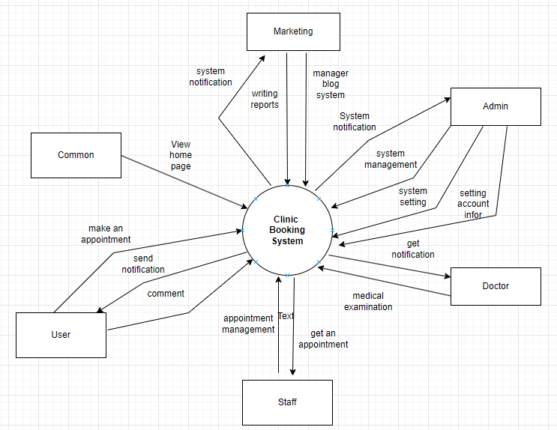

## 

## 

## 

## 

## 

## 

## 

## 

## 

## **2. System Functions**

### **a.** **Screen Flow**

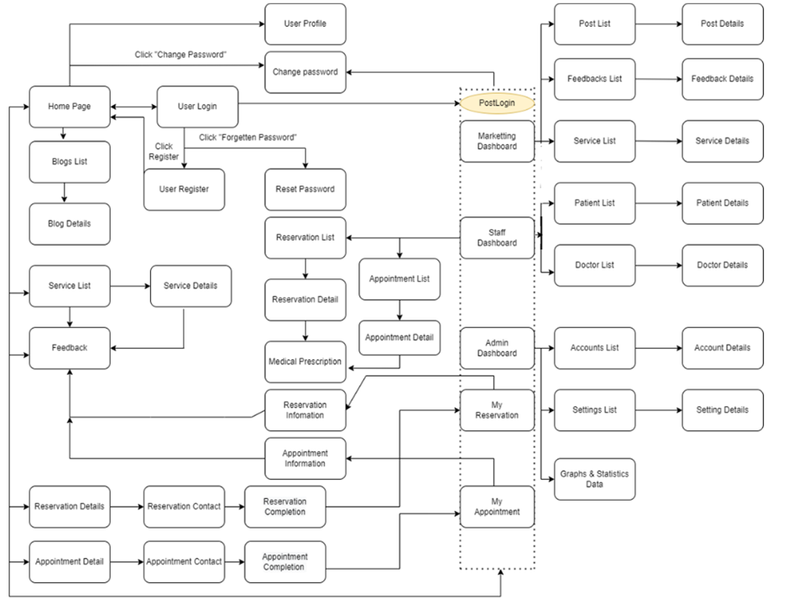

***Image 1.2: Screen flow of Clinic system***

### **b.** **Screen Details**

| **Feature** | **Screen** | **Description** |
| --- | --- | --- |
| Public | Home Page | the starting page of the system |
| Public | Blogs List | list of shared posts |
| Public | Blog Details | detail of the shared post |
| Public | Services List | list of the active type of services |
| Public | Service Details | Details of the selected service |
| Public | Reservation Details | details of the user reservations (the list of selected services to reserve) |
| Public | Reservation Contact | screen that allows user to input/edit the reservation receiver |
| Public | Reservation Completion | reservation completion screen |
| Common | User Login | authenticate the user to give him/her to access authorized features later on |
| Common | User Register | register a new user into the system, verified by the registered email |
| Common | Reset Password | use in case the user forgot his/her password |
| Common | Change Password | change user’s login password |
| Common | User Profile | view & edit/update user profile |
| Common | User Authorization | Authorization user into the system functions based on his/her role |
| Patient | My Reservation | for the customer to view his/her submitted reservations |
| Patient | Reservation Information | to show Patient reservation details, the Patientcan edit or cancel the reservation when it is still in the submitted status |
| Patient | My Appointment | for customer to view his/her submitted Appointment |
| Patient | Appointment Information | to show Patient Appointment details, the Patientcan edit or cancel the Appointment when it is still in the submitted status |
| Staff | Services List | list, filter, search, view service(s) |
| Staff | Service Details | view the details of a specific service |
| Staff | Reservation List | Show list reservations.  - Shown columns: Id, patient name, service name, time, status  - Staff can see all the service |
| Staff | Appointment List | Show list appointments.  - Shown columns:Id, Patient Name, Doctor Name, Time, Status  - staff can view all appointments |
| Staff | Reserve a Service | Show detail appointment  - Shown properties:avatar, name, mobile, gender, date of birth,avatar, name, mobile, gender, speciality,date, time, status, description, in-charged staff. |
| Staff | Reservation Details | view the details of a specific assigned reservation. |
| Staff | Appointment Details | view the details of a specific assigned Appointment. |
| Staff | Medical examination | list, filter, search, show, hide, view the history examination of a customer that is assigned for this staff. |
| Staff | Services List | list, filter, search, show, hide, view service(s) |
| Staff | Service Details | view the details of a specific service |
| Staff | Customers List | list, filter, search, show, hide, view customer/contact(s) |
| Staff | Customer Details | view the details of a specific customer |
| Staff | Feedbacks List | list, filter, search, show, hide, view feedback(s) |
| Staff | Feedback Details | view the details of a specific feedback |
| Staff | Medical Prescription | (Used for doctor) list, filter, search, show, hide, view, add new prescription |
| Marketing | Services List | View list of service in system includes: ID, tên dịch vụ, loại, giá, trạng thái, chỉnh sửa dịch vụ.   * The admin can add new service. * The admin can search service by name or category. * The user can view feedback of other patents when click double on a service in service list. |
| Marketing | Service Details | Show detailed service information (title, category, price, thumbnail, status, description), from that allow the user to add new, view or edit service information. |
| Staff | Patient List | List of patients in the system (search by name) with following columns: Id, patient name, gender, date of birth, and status. |
| Staff | Patient Details | - View details of a specific patient (chose from the Patients List screen), from this screen:  - The user can see the avatar, full name, email, gender, DOB, phone, email,status. -The user can activate or deactivate a patient.  - The user can also choose to edit the patient information via the Patient Edit screen. |
| Staff | Doctor List | List of doctors in the system:  - Shown columns: Id, doctor name, gender, speciality, status.  - The user can search the doctors by name, filter them by gender & speciality. |
| Staff | Doctor Details | View details of a specific doctor (chosen from the Doctors List screen):  - The following information of the doctor is shown: name, Role, gender, DOB, Phone, Email, Status, Description.  - The user can also choose to edit the doctor information via the Doctor Edit screen. |
| Staff | Doctor Edits | Edit doctor information which include: name, gender, DOB, Phone, doctor role, speciality, description. |
| Staff | Patient Edits | Edit Patient information, including name, patients_id, gender, DOB, phone, address, status. |
| Marketing | Service Add | The user can add images, title, category, price, description, status. |
| Marketing | Service Edit | Edit service information which include: images, title, category, price, description, status. |
| Admin | Admin Dashboard | view general statistics & trends about the management-related data |
| Admin | Accounts List | Account list feature displays a list of all accounts created on the system including Admin, Patient, Doctor.  - Shown columns: tên tài khoản , học tên , giới tính , Email , số điện thoại ,quyền, trạng thái, chỉnh sửa  - Admin can also edit the account  -Admin can find the account by name |
| Admin | Accounts Details | Account detail feature displays user details information  - Shown properties: “Tên tài khoản”,“Họ và tên”, “Quyền”, “Tình trạng”, “Giới tính”, “Email”, “số điện thoại” |
| Admin | Settings List | Show the paginated list of settings  - Shown columns:Setting ID, Type, Value, Order , Note , status , edit  -admin can search by value ,or filter by type |
| Admin | Setting Details | This function is activated when the user clicks on button edit  Setting Details(Edit):  - Shown properties:Setting ID,, Value, Order , Note , status , edit |
| Admin | Graphs & Statistic Data | Graphs & Statistics of Doctors, Patients, Appointments, and Revenue |

***Table 1.1****: Screen detail table of clinic system*

### **c.** **User Authorization**

| **Screen** | **Admin** | **Marketing** | **Staff** | **Doctor** | **Patient** | **Guest** |
| --- | --- | --- | --- | --- | --- | --- |
| **Home Page** | X | X | X | X | X | X |
| **Doctors List** | X |  | X | X | X | X |
| **Doctor Details** | X |  | X | X | X | X |
| **Active/Deactive a doctor** |  | X |  |  |  |  |
| **View his/her appointments** |  | X |  | X |  |  |
| **Doctor Edit** |  |  |  |  |  |  |
| **Services List** | X | X | X | X | X | X |
| **Add new service** |  | X |  |  |  |  |
| **Service Details** | X | X | X | X | X | X |
| **Edit service information** |  | X |  |  |  |  |
| **Service Feedbacks** |  | X |  |  |  |  |
| **Blogs List** | X | X | X | X | X | X |
| **Blog Details** | X | X | X | X | X | X |
| **User Login** | X | X | X | X | X | X |
| **User Register** | X | X | X | X | X | X |
| **Forgot Password** | X | X | X | X | X | X |
| **Change Password** | X | X | X | X | X | X |
| **User Profile** | X | X | X | X | X | X |
| **Dashboard** | X |  |  |  |  |  |
| **Accounts List** | X |  |  |  |  |  |
| **Account Details** | X |  |  |  |  |  |
| **Patients List** |  |  | X |  |  |  |
| **Patient Details** |  |  | X |  |  |  |
| **Patient Edit** |  |  | X |  |  |  |
| **Appointments List** |  |  | X |  |  |  |
| **Appointment Details** |  |  | X |  |  |  |
| **Reservations List** |  |  | X |  |  |  |
| **Reservation Details** |  |  | X |  |  |  |
| **Settings List** | X |  |  |  |  |  |
| **Setting Details** | X |  |  |  |  |  |
| **My Appointments** |  |  |  | X |  |  |
| **My Appointment Details** |  |  |  | X |  |  |
| **My Patients** |  |  |  | X |  |  |
| **My Patient Details** |  |  |  | X |  |  |
| **My Feedbacks** |  |  |  | X |  |  |
| **Book Appointment** |  |  |  |  | X |  |
| **Reserve a Service** |  |  |  |  | X |  |
| **Appointment History** |  |  |  |  | X |  |
| **Reservation History** |  |  |  |  | X |  |

***Table 1.2****: User authorization table of clinic system*

### **d.** **Non-Screen Function**

| **#** | **Feature** | **System Function** | **Description** |
| --- | --- | --- | --- |
| 1 | Common | Sign out | Users sign out of the system |
| 2 | Common | User Authorization | This is the authorization mechanism in the system, |

***Table 1.3****: Non-screen function table of clinic system*

# 

# 

# **II. Functional Requirements**

# **1. Public Feature**

#### **a. Home Page**

● ***Function trigger:***

* Navigation Path: This function is triggered when the user visits the website or the system homepage
* Frequency of Use : High.
* Priority: High.

● ***Function description:***

* Actor: Common.
* Purpose:
* Users see briefs about introduction.
* Display top services, top doctors, the system's specialties.
* Data processing: Select doctor_name, img in doctor table inner join name in category_service table and select service_name, img in service table inner join category_service table in database and list them in website.

● ***Screen layout:***

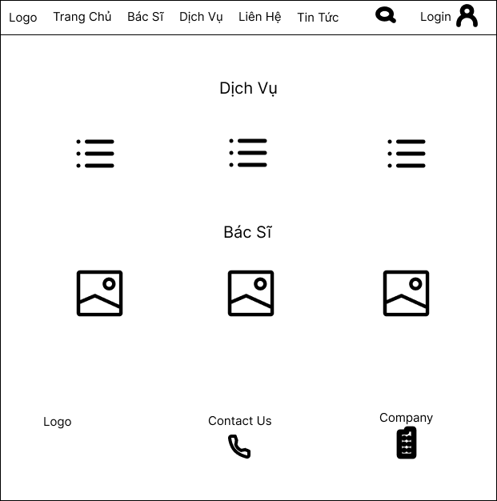

* **Function Details:**
* Business logics: When users access the system, the homepage will appear and show information about the system and show: random 6 Service, random 8 Doctor.
* Normal case:If login successful , the screen will display that homepage .
* Abnormal case: If you can't find the internet the screen will not show .

#### **b. Web Blog List**

# ● **Function trigger:**

* Navigation Path:This function is triggered when the user clicks blogs in navbar
* Frequency of Use : High.
* Priority: High.

# ● **Function description:**

* Actor:Common

# Purpose :User view the paginated list of blogs.Display the all blog, top 5 blog, categories.

* Data processing:Get data from Blog table in database then list them on screen.

● **Screen layout:** mock-up prototype of the screen, sample below is for the Blog screen

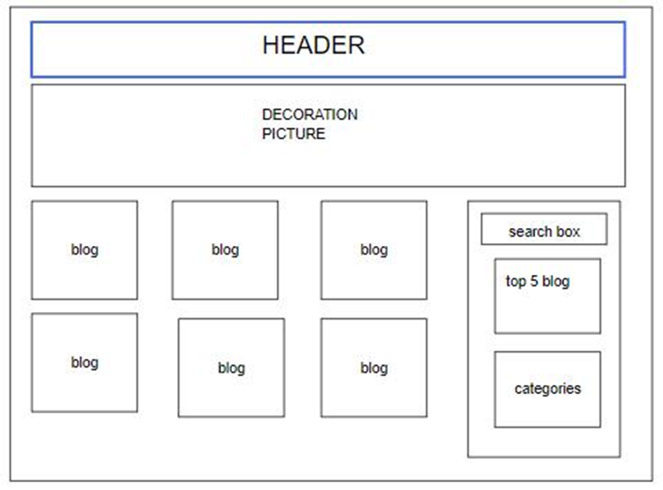

● **Function Details:**

* + Data:blog, categories
  + Business logics:Show the posts pagination (sorted by updated date)
  + The right sider with the post search box, post categories, five featured posts (thumbnail, title)
  + Post information includes its thumbnail, title, category, post date, brief-info
* Normal case:If searching for a blog, the screen will display that blog name searching for the words that the user searched for.
  + Abnormal case: If you can't find the blog name whose name contains the user's search terms, the screen will not show the blog.

# 

#### **c. Web Blog Details**

● **Function trigger:**

* Navigation Path:This function is triggered when the user clicks to Read More or Title
* Frequency of Use : Low.
* Priority: Low.

● **Function description:**

* Actor:Common
* Purpose:User view detail information of blog .Display including title, author, updated date, brief info, and post content.
* Data processing:Get data from Blog table in database then list them on screen.

● **Screen layout:** mock-up prototype of the screen, sample below is for the Details screen

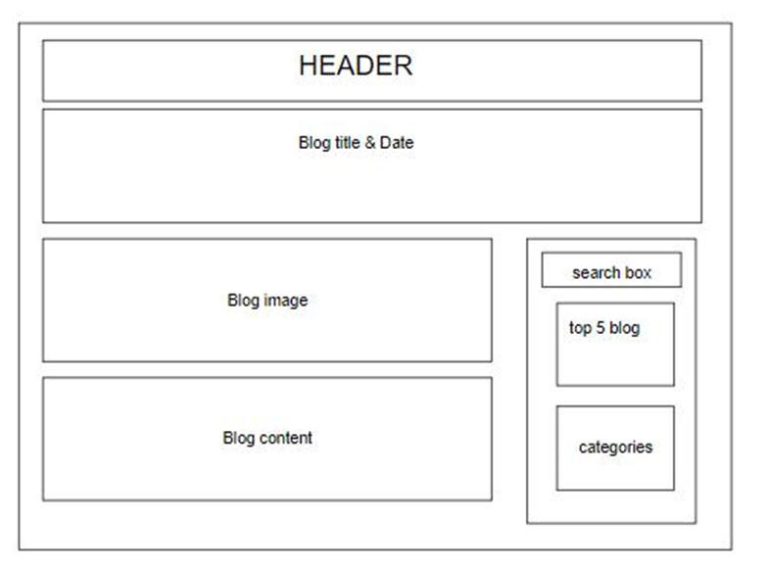

● **Function Details:**

* Data:title, author, updated date, brief info.
* Business logics: The right sider with the post search box, post categories, five featured posts (thumbnail, title).
* Normal case:If chosen for a blog detail, the screen will display that blog detail for the words.
* Abnormal case: If you can't find the internet the screen will not show.

#### **d. Web Doctor List**

● **Function trigger:**

* Navigation Path:This function is triggered when the user clicks to Doctor List
* Frequency of Use : High.
* Priority: High.

●  **Function description:**

* Actor:Common
* Purpose:Users view detailed information about the Doctor.
* Shown information of each doctor: avatar, role, speciality, rated star, and number of feedbacks.
* Data processing:Get data from the doctor table in the database then list them on screen.

● **Screen layout:** mock-up prototype of the screen, sample below is for the Doctor List screen

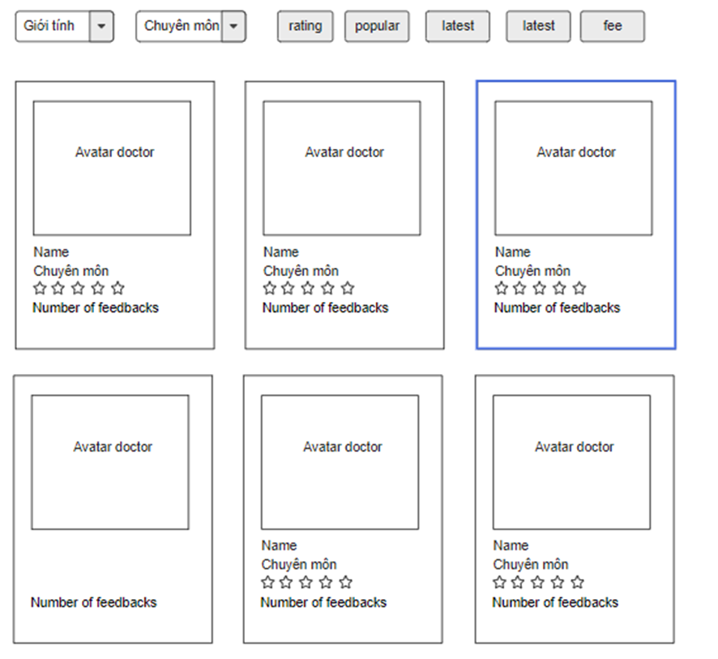

● **Function Details:**

* Data: avatar, role, speciality, rated star, and number of feedbacks.
* Business logics: User choose to view Doctor Details or Book Doctor
* Normal case:If chosen for a doctor, the screen will display that doctor chosen for the words that the user chose for.
* Abnormal case: If you can't find the doctor whose name contains the user's chosen terms, the screen will not show the doctor .

#### **e. Web Service List**

●  **Function trigger:**

* Navigation Path:This function is triggered when the user clicks to Services List
* Frequency of Use : High.
* Priority: High.

● **Function description:**

* Actor :Common
* Purpose:User view detail information of Services
* Shown information for each service include: title, category, rated star, number of feedbacks, service fee and description.
* Data processing:Get data from the service table in the database then list them on screen.

● **Screen layout**: mock-up prototype of the screen, sample below is for the Services List screen

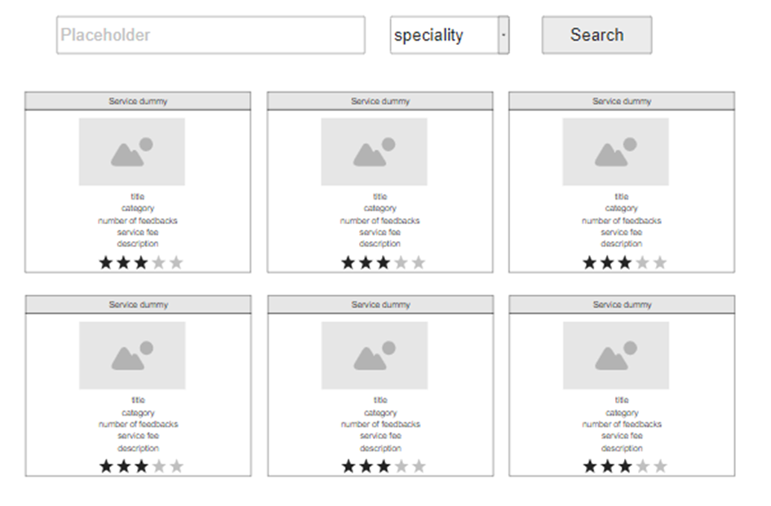

●  **Function Details:**

* Data:title, category, rated star, number of feedbacks, service fee and description
* Business Logic: User can search by name; filter by speciality; sort by the fee or the name
* Normal case:If searching for a service, the screen will display that service searching for the words that the user searched for.
  + Abnormal case: If you can't find the serviceservice whose name contains the user's search terms, the screen will not show the serviceice.

# 

# **2. Common Feature**

#### **a. Sign in**

● **Function trigger:**

* Navigation Path:This function is triggered when the user clicks Sign in from Homepage.
* Frequency of Use : High.
* Priority: High.

● **Function description:**

* Actor:Common
* Purpose:User sign in into the system.
* Data processing:Get data from the User table in the database.

● **Screen layout:** mock-up prototype of the screen, sample below is for the Sign in screen

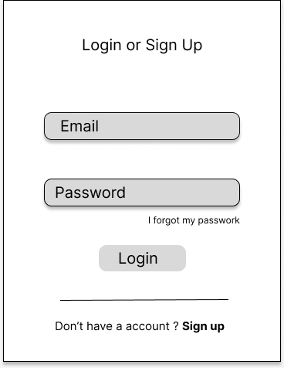

● **Function Details:**

* Data:Username,userId,password .
* Business Logic:When the user is in the state not logged in, at the home page there will be a Sign in button after signing in into the system, the Sign in button will become Sign out.
* Retrieve the username and password entered by the user.
* Validation:Validate the input to ensure it meets any specified requirements (e.g., length, format).
* Query the database or user repository to retrieve the stored user information associated with the provided username.
* Compare the stored password (usually stored in a hashed form) with the provided password.
* If the passwords match, generate a session token or set a session cookie to keep the user authenticated.
* Return true to indicate a successful login.
* If the passwords do not match or the user is not found, return false to indicate a failed login
* Normal case:
* The user enters the correct login information and will be redirected to the homepage
* Abnormal cases:
* If the user enters the wrong format, the screen will display the information: login failed!".
* If the user enters the wrong password, the screen will display the information: "the password must have at least 8 characters including uppercase, lowercase and special characters".
* If the user enters the wrong new password, the screen will display the information: "the password must have at least 8 characters including uppercase, lowercase and special characters".

#### **b. Register**

● **Function trigger:**

* Navigation Path:This function is triggered when the guest goes to login and choose to register.
* Frequency of Use : Low.
* Priority: Low.

● **Function description:**

* Actor:Common
* Purpose:The guest can create an account.
* Data processing:Get data from the User table in database.

# ● **Screen layout:** mock-up prototype of the screen, sample below is for the Register.

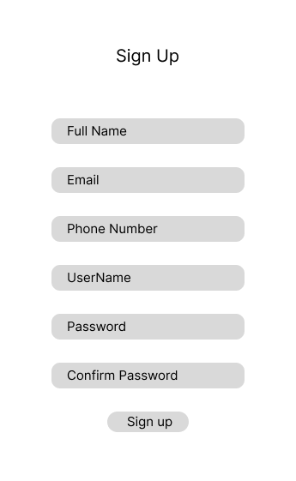

● **Function Details:**

* Data :username,email,phone,password.
* Business Logic:The sign-up function allows users to create an account within a system.It involves collecting user information such as name, email, username, and password.
* Validation:
* Validate input format: Perform basic validation checks on the entered data. For example, you can ensure that the username and password are not empty, the email address is in a valid format, and the date of birth follows a specific pattern.
* Verify uniqueness: Check if the entered username or email address is already registered in the system. This step ensures that each user has a unique identifier and prevents duplicate entries.
* Once completed, users receive welcome messages to initiate their experience with the system
* Normal case:
* The user enters the correct login information and will be redirected to the login
* Abnormal case:
* If the user enters the wrong format, the screen will display the information: registration failed!".

#### **c. Change Password**

● ***Function trigger:***

* Navigation Path: This function is triggered when the user clicks “Tài khoản của tôi” from avatar in Homepage.
* Frequency of Use : Low.
* Priority: Low.

● ***Function description:***

* Actor: Common
* Feature:
* Users can change passwords.
* Data processing:System will authenticate user request -> process request -> encrypt password -> update password to database -> send notification to user.

● ***Screen layout:*** simulated prototype of screen, below sample is for ChangePassword screen

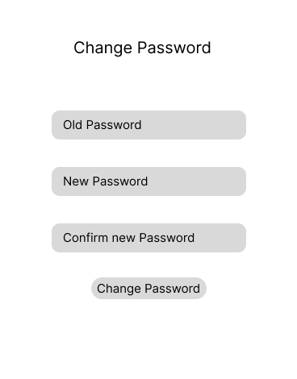

* **Function Details:**
* Business logics: System will authenticate user request -> process request -> encrypt password -> update password to database -> send notification to user.
* Validate:
* Current Password Verification: To ensure the account owner is the one initiating the password change, the user is usually required to enter their current password as a verification step.
* New Password Creation: The user is prompted to enter a new password. Strong password requirements are often enforced to enhance security, such as minimum length, a combination of uppercase and lowercase letters, numbers, and special characters.
* Password Confirmation: To prevent any typographical errors, the user is typically asked to re-enter the new password to confirm it matches the desired password.
* Once completed, users receive messages successful
* Normal case:
* The user enters the correct login information and the new password is valid. The password change process is successful, the new password is updated in the database and the user receives a successful notification of the password change.
* Abnormal cases :
* If the user enters the wrong old password, the screen will display the information: "The old password is not correct!".
* If the user enters the password in the wrong format, the screen will display the information: "the password must have at least 8 characters including uppercase and lowercase digits and special characters".
* If the user enters the new password in the wrong format, the screen will display the information: "password must have at least 8 characters including uppercase and lowercase digits and special characters".
* If the user re-enters the new password but does not match the new password, the screen will display the information: "password does not match".

#### **d. Forgot Password**

● **Function trigger:**

* Navigation Path: This function is triggered when the user clicks “i forgot my password” from Login.
* Frequency of Use : Low.
* Priority: Low.

● **Function description:**

* Actor:Common
* Purpose:The user can Forgot Password to an account.
* Data processing:Get data from the User table in the database.

# ● **Screen layout:** simulated prototype of screen, below sample is for ForgotPassword screen

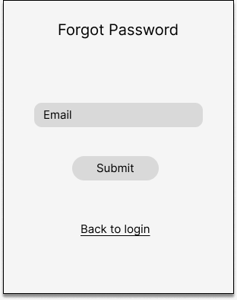

● **Function Details:**

* Business Logic:
* Password Recovery Option: On the login page, there is a button labeled "Forgot Password" . The user can click on this option to initiate the password recovery process.
* Account Verification: To ensure the security of the account, the user is usually required to provide information for verification purposes. This can include entering the registered email address associated with the account.
* Reset Password Link : Once the account verification is successful, the system sends a verification link to the user's registered email address. The link or code is sent as a means of confirming the account ownership and providing access to reset the password.
* Normal case:
* The user enters the correct Forgot password information and will be redirected to complete
* Abnormal case:
* If the user enters the wrong password, the user cannot retrieve the password.

# 

#### **e. User profile**

● **Function trigger:**

* Navigation Path: This function is triggered when the user clicks “Tài khoản của tôi” from avatar in Homepage.
* Frequency of Use : Low.
* Priority: High.

● **Function description:**

* Purpose:The user can edit profile information, including the registered user information and the avatar image.
* Edit User profile information which include : username,full name,phone ,avatar.
* Data processing:Get data from the User table in the database.

● **Screen layout:**

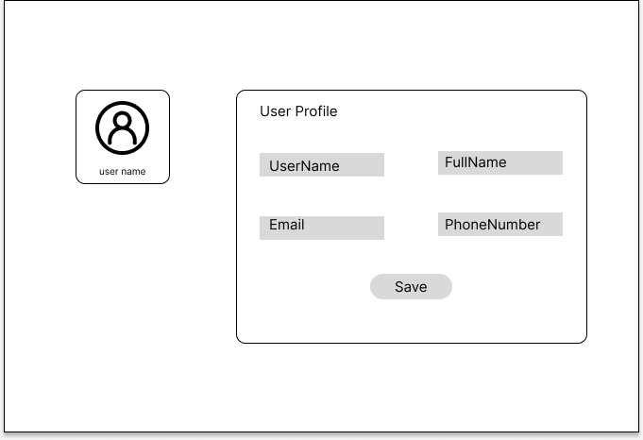

● **Function Details:**

* Data:UserName,email,phone ,avatar.
* Business Logic
* Profile Picture: Users can upload or choose a profile picture to represent their identity within the system or application.
* Edit and Update: Users should have the ability to edit and update their profile information as needed. This can include modifying personal details, changing the profile picture, or updating the biography.
* Normal case:
* If the user clicks the Profile , the user can update and edit the profile.
* Abnormal case:
* If the user is not logged in, the user cannot access the user information.

# **3. Admin Feature**

#### **a. Settings List**

* **Function trigger:**
* Navigation Path: When a user logs in as admin, the page is automatically redirected here.
* Frequency of Use : High.
* Priority: High.
* **Function description:**
* Actor: Admin
* Purpose:
* Shown columns:Setting ID, Type, Value, Order , Note , status , edit
* Admin can search by value ,or filter by type
* Data processing
* **Screen layout:** simulated prototype of screen, below sample is for admin setting screen

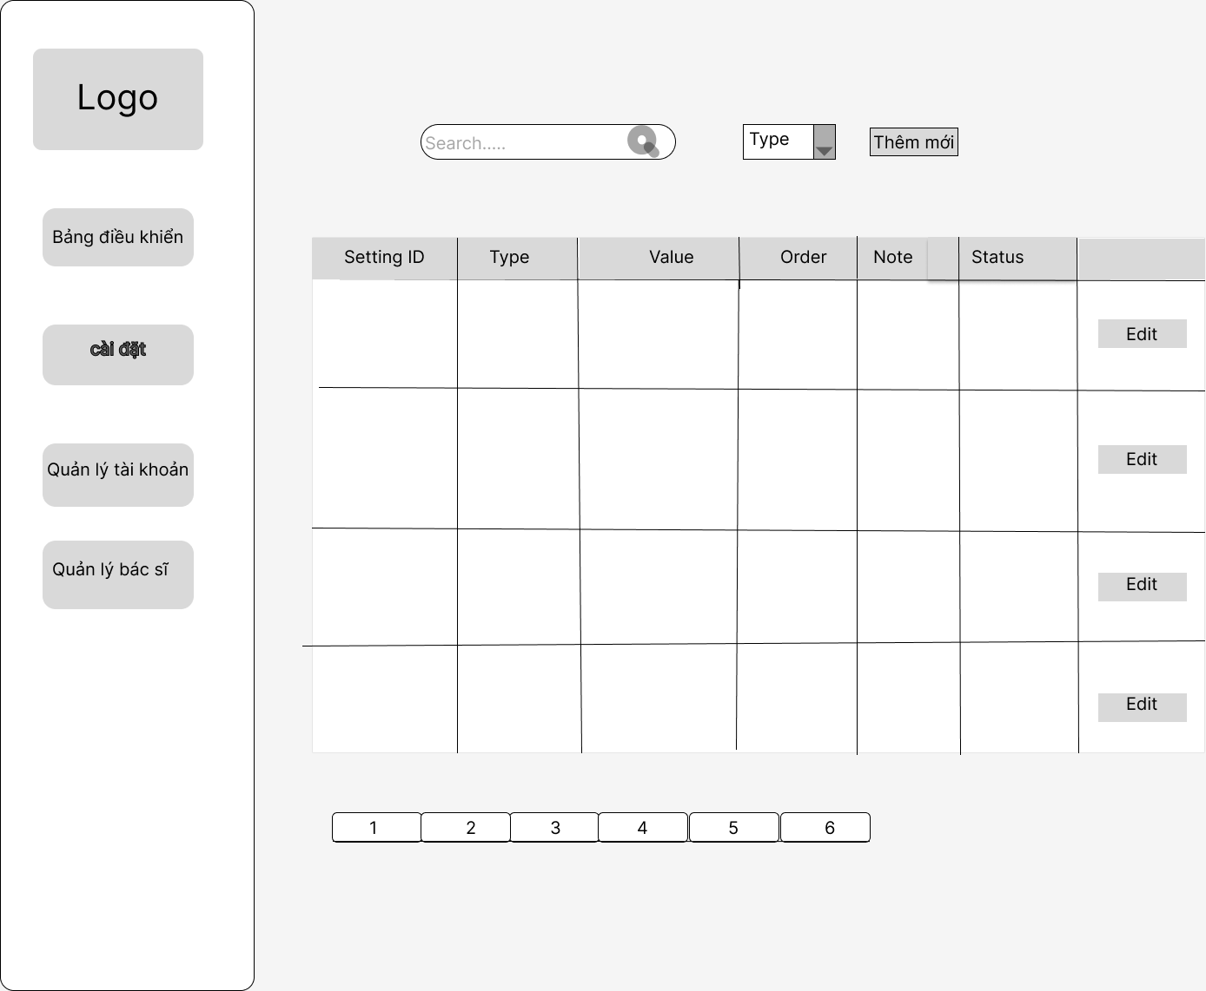

* **Function Details:**
* Data: Shown columns:Setting ID, Type, Value, Order , Note , status
* Business logics:
* Allow the admin to search settings by value, from each setting, the admin can choose to view, activate/deactivate, or edit it
* Has the attributes :Setting ID, Type(with types such as :user,blog) , Value(with values such as: Admin, Patient,Doctor) , Order , Note , status(with two states: Active and Disabled) , edit
* Admin can search by value ,or filter by type(user, blog)
* Admin can also edit the account.

**-** Normal case:

* When the administrator searches, if it is correct, the screen will show the information that the administrator is looking for
* Abnormal case:
* Admin search if the value is not correct or not present will show an empty list
* When the administrator loses the network then the table information is not displayed

#### **b. Setting Details**

* **Function trigger:**
* Navigation Path:This function is activated when the user clicks on button edit
* Frequency of Use : Low.
* Priority: Low.
* **Function description:**
* Purpose: add new setting
* Actor: Admin
* Purpose:
* Shown properties:Setting ID,, Value, Order , Note , status , edit
* Data processing When the administrator uses Setting Details to edit: Setting_id, Valu, Oder, Note, Status., this data will be sent and updated to the database.

* **Screen layout:** simulated prototype of screen, below sample is for add setting screen

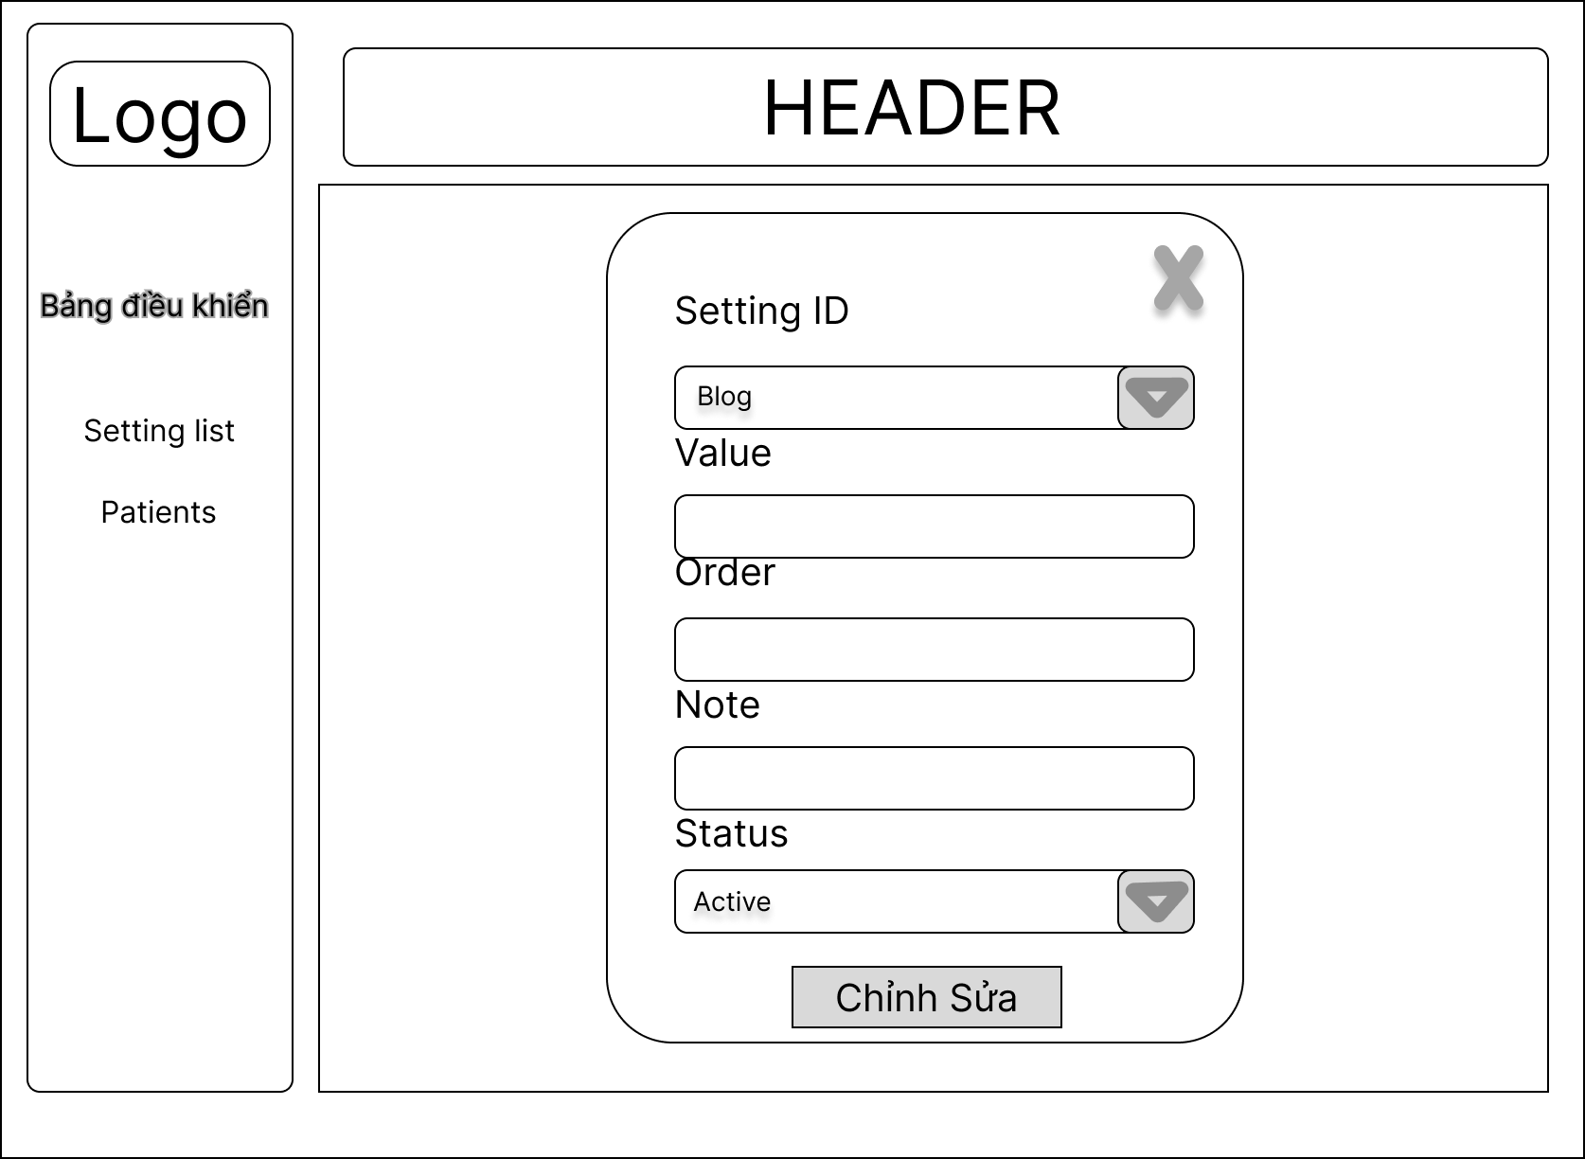

**Function Details:**

* Data: Shown properties:Setting ID,, Value, Order , Note , status , edit
* Business logics:
* Edit Setting information which include: Setting ID(with types such as :user,blog),value(with values such as: Admin, Patient,Doctor), order, note, status(with two states: Active and Disabled).
* Edit Setting information which include: Setting ID(with types such as :user,blog),value(with values such as: Admin, Patient,Doctor), order, note, status(with two states: Active and Disabled).
* Normal case:
* Admin successfully edit the screen will say "edit successfully"
* Abnormal case:
* If the administrator enters the wrong data format, there will be a message "edit failed" and ask to rewrite the edited data.

#### **c. Account List**

* **Function trigger:**
* Navigation Path: When a user logs in as admin, the user chooses “Quản lý tài khoản” feature
* Frequency of Use : Low.
* Priority: Low.

**Function description:**

* Purpose :Account list feature displays a list of all accounts created on the system including Admin, Patient, Doctor.
* Actor:Admin
* Account List:
* Shown columns: tên tài khoản , học tên , giới tính , Email , số điện thoại ,quyền, trạng thái, chỉnh sửa
* Admin can also edit the account
* Admin can find the account by name
* Data processing When the administrator wants to see the data account list of attributes .username, name, gender, email, phone, role_id, status, then the data from the user table will be uploaded by the database and appear on the screen

**Screen layout:** simulated prototype of screen, below sample is for admin setting screen

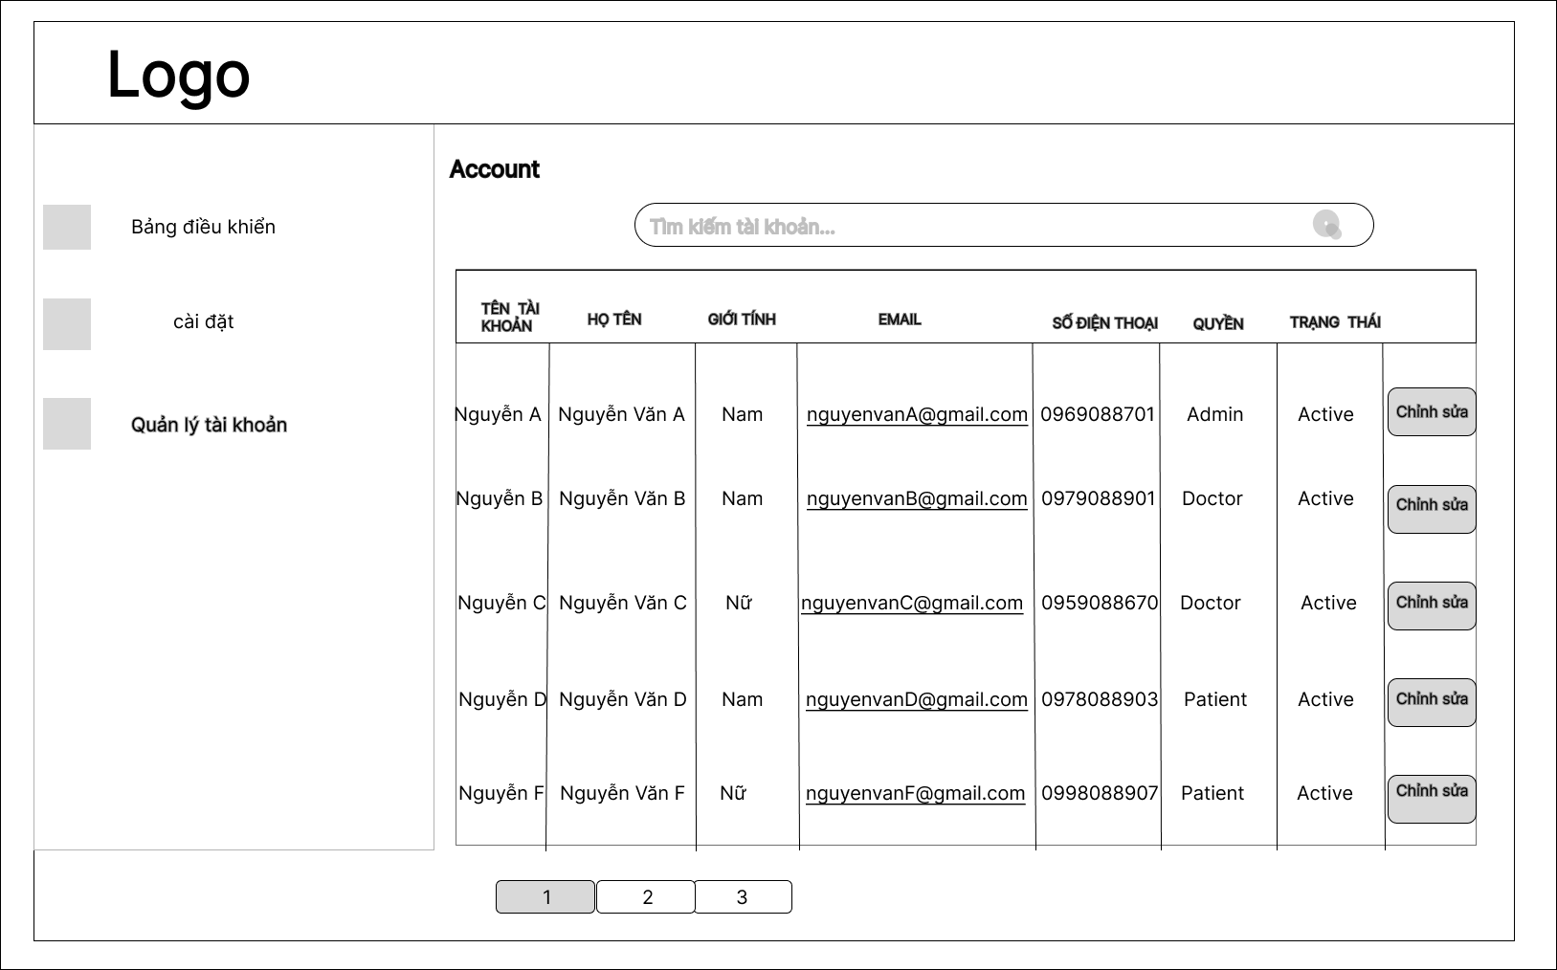

*Image: The mockup of Account list in Doctris system*

**Function details:**

* Data: Shown columns: tên tài khoản , học tên , giới tính , Email , số điện thoại ,quyền, trạng thái
* Business logics:
* Allows administrators to look up account names, display a list of accounts and edit accounts of administrators, patients, and doctors.Include
* Admin can also edit the account
* Has the following attributes: tên tài khoản , học tên , giới tính , Email , số điện thoại ,quyền(with values such as: Admin, Patient,Doctor) , trạng thái(with two states: Active and Disabled), chỉnh sửa
* Admin can also edit the account
* Admin can find the account by name
* Normal case:
* When the administrator wants to search for an account, he will click on the search bar and search for an account by name, then the screen will display a list of searched account names.
* Abnormal case:
* If the admin searches for an account by name but the account doesn't exist, the screen will show an empty list

#### **d. Account Detail**

**● Function description:**

* Purpose:Account detail feature displays user details information
* Actor: Admin
* Account Detail :
* Show properties: “Tên tài khoản”,“Họ và tên”, “Quyền”, “Tình trạng”, “Giới tính”, “Email”, “số điện thoại”.
* Data processing: Select username , password , name ,gender, phone, email , img , status, from the Account table.

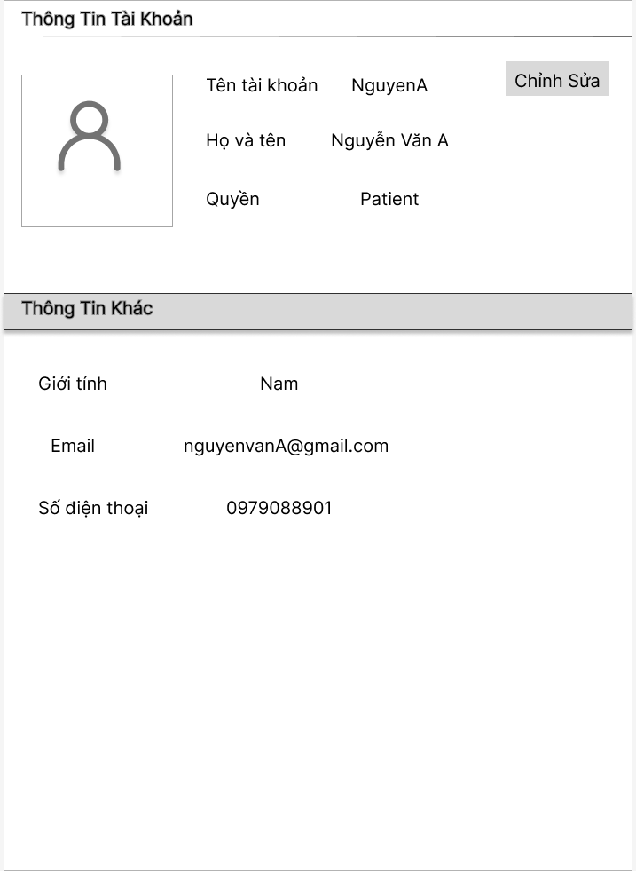

● **Function Details**:

* Data: Show properties: “Tên tài khoản”,“Họ và tên”, “Quyền”, “Tình trạng”, “Giới tính”, “Email”, “số điện thoại”
* Business logics**:**
* Allow the admin can view and edit user accounts in the Doctris system includes “Tên tài khoản”,“Họ và tên”, “Quyền”, “Tình trạng”, “Giới tính”, “Email”, “số điện thoại”

#### **e. Dashboard**

* ***Function trigger:***
* Navigation Path: When a user logs in as admin, then the page is automatically redirected here.
* Frequency of Use: High.
* Priority: High.
* ***Function description:***
* Actor: Admin.
* Purpose:
* The user can see graphs and statistics of Doctors, Patients, Appointments, and Revenue.
* List of today related appointments (Patient name, doctor name, date/time, Status.
* Data processing: Select number of doctors, number of patients, number of appointments, number of reservations in the database and list them in the website.
* ***Screen layout:*** simulated prototype of screen, below sample is for doctor list screen.

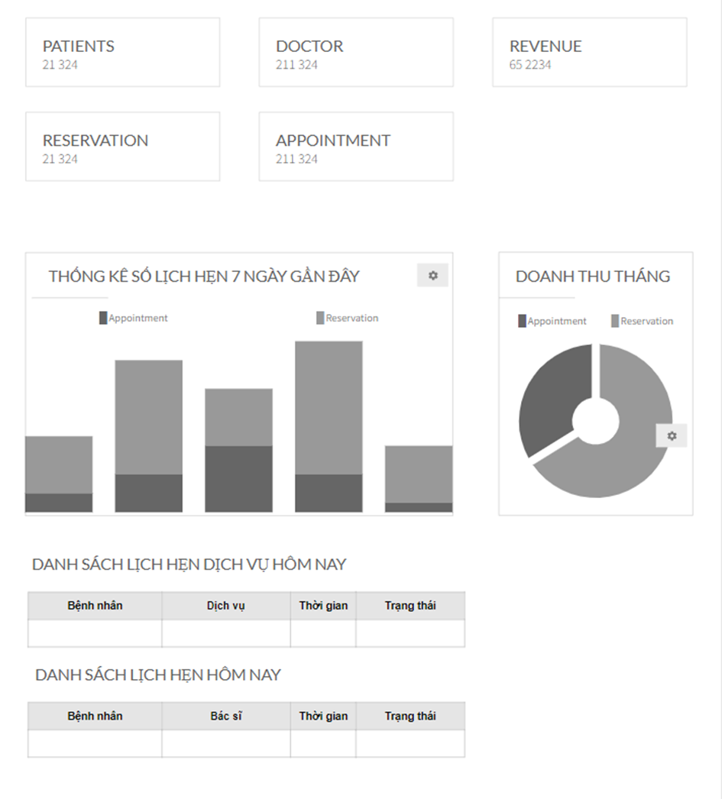

* ***Function Details:***
* Data: Graphs and Statistics of Doctors, Patients, Appointments, and Revenue.
* Business logics:
* The user can see the sum of doctors, patients, appointments, reservation and revenue.
* The user can also choose to see graphs and statistics of reservation, appointments in 3 days, 7 days, 14 days.
* The user can also choose to see revenue of reservation, appointments in 3 days, 7 days, 14 days.
* The user can see list of today related appointments (patient name, doctor name, date/time, status).
* Normal case:
* When user login success graphs and statistics of doctors, patients, appointments, and revenue.
* When a user login the success list of today related appointments (patient name, doctor name, date/time, status).
* Abnormal case:
* When the website does not connect the error page will appear.

# **4. Marketing Feature**

#### **a. Service List**

**● *Function trigger:***

* Navigation Path: Function works when user click on Service button.
* Frequency of Use : High.
* Priority: High.

**● *Function description:***

* Actor: Marketing.
* Data processing: Select service_id, sevice_name, category, fee, status from Service table in database then list them in screen..
* View list of service in system includes: ID, tên dịch vụ, loại, giá, trạng thái, chỉnh sửa dịch vụ.
* The admin can add new service.
* The admin can search service by name or category.
* The user can view feedback of other patents when click double on a service in service list.

**● *Screen layout:*** Simulated prototype of screen, below sample is for admin account screen.

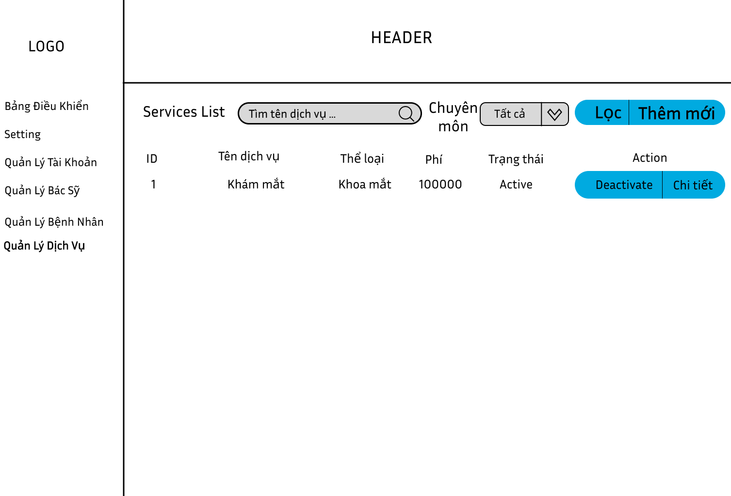

* ***Function Details:***
* Data:
* Show following columns: id, title, category, price, status, action (edit, activate/deactivate).
* Search by name, filter by category.
* Business logics :
* From this page, users can choose to add new or edit a service (the Service Details page is called); the user can also double click on a service to see the feedback on the service from patients (via the Service Feedbacks page).
* When the user clicks “Deactivate”, this service will stop working.
* Normal case:
* If searching for a service's name, the screen will display that service's name searching for the words that the user searched for.
* Abnormal case:
* If you can't find the services's name whose name contains the user's search terms, the screen will not show the service list.

#### **b.Service Details**

* ***Function trigger:***
* Navigation Path: This function is activated when the user clicks on manage 1 button chi tiết.
* Frequency of Use : High.
* Priority: High.
* ***Function description:***
* Actor: Marketing.
* Data processing: Select title, category, price, status, description from service table in database and list them to website.
* Purpose: Show detailed service information (title, category, price, thumbnail, status, description), from that allow the user to add new, view or edit service information.
* ***Screen layout:*** Simulated prototype of screen, below sample is for admin Services screen.

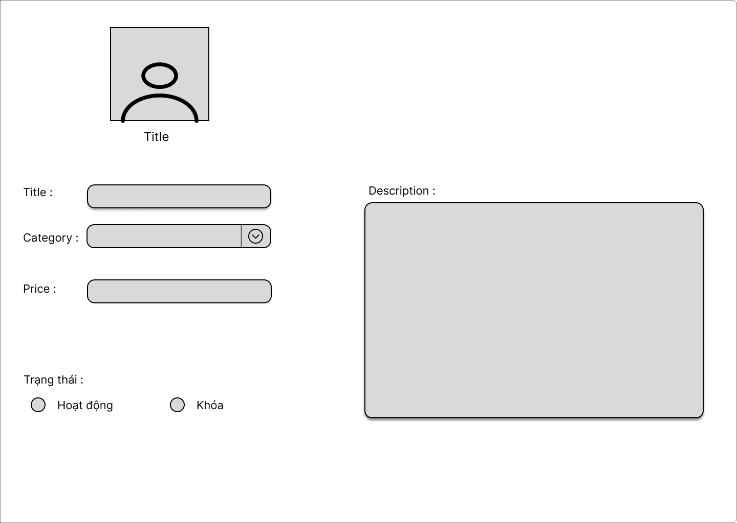

* ***Function Details:***
* Data: Show detailed service information (title, category, price, thumbnail, status, description), from that allow the user to add new, view or edit service information.
* Business logics :
* when the user is to the use of the “chi tiết” button can view service information in it.

#### **c.Service Adds**

● ***Function trigger:***

* Navigation Path: This function is activated when the user clicks on button add.
* Frequency of Use : Low.
* Priority: Low.

● ***Function description:***

* Actor: Marketing.
* Data processing: When user add new information of service then this data will send and insert in the database.
* Purpose: The user can add images, title, category, price, description, status.

● ***Screen layout:*** Simulated prototype of screen, below sample is for add Service screen

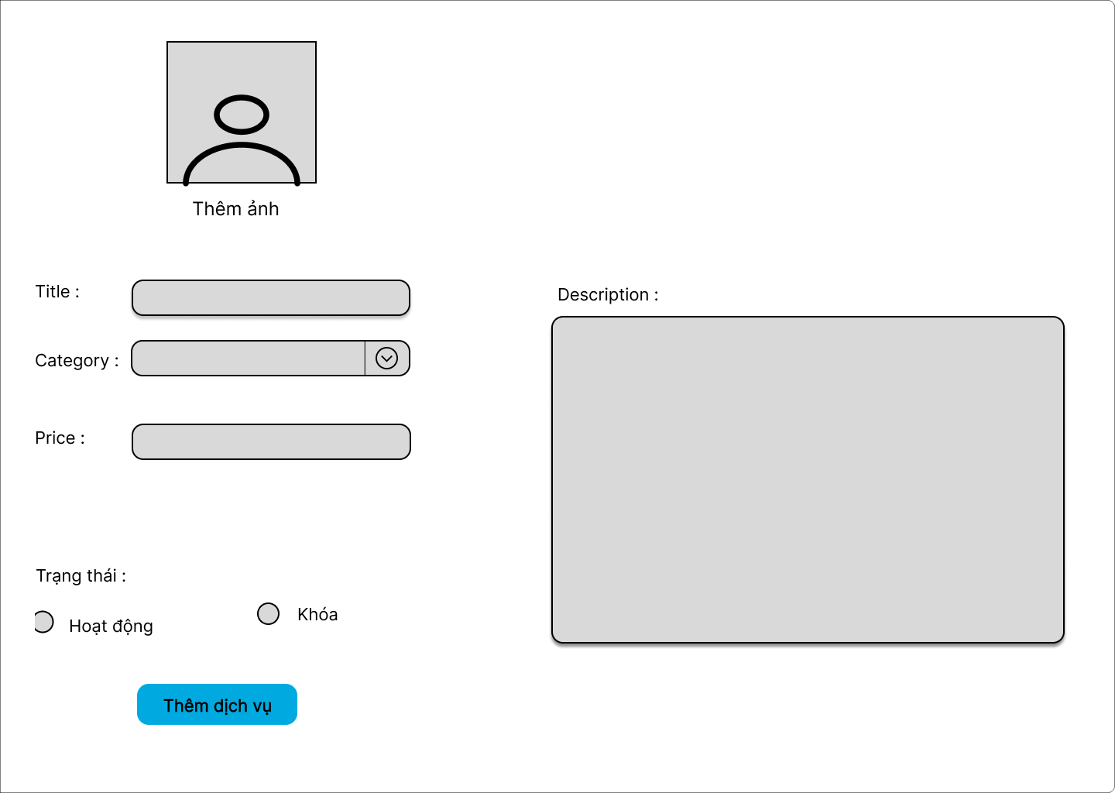

* ***Function Details:***
* Data**:** The user can add images, title, category, price, description, status.
* Validate:
* When the user enters the text in the price will be displayed to enter the number.
* Business logics :
* when the user is to the use of the “them dich vu” button can add service information.
* Normal case:
* The administrator or person with permission to add the service enters the correct information of the new service. Adding the service is successful, and the information about the new service is stored in the database. The user receives a success message about adding the service.
* Abnormal case:
* When the user choose “Khoa”, this service won’t appear.
* When the user choose “Hoat dong”, this service will appear.
* When the user forgets to fill in the information in the fields, when pressing "save" the computer screen will show a message to fill in all the information in that field.

#### **d.Service Edit**

**● *Function trigger:***

* Navigation Path: This function is activated when the user clicks button edit.
* Frequency of Use : Low.
* Priority: Low.

**● *Function description:***

* Actor: Marketing.
* Data processing: When user change information of service then this data will send and update in database.
* Purpose: Edit service information which include: images, title, category, price, description, status.

**● *Screen layout:*** Simulated prototype of screen, below sample is for Service edit screen.

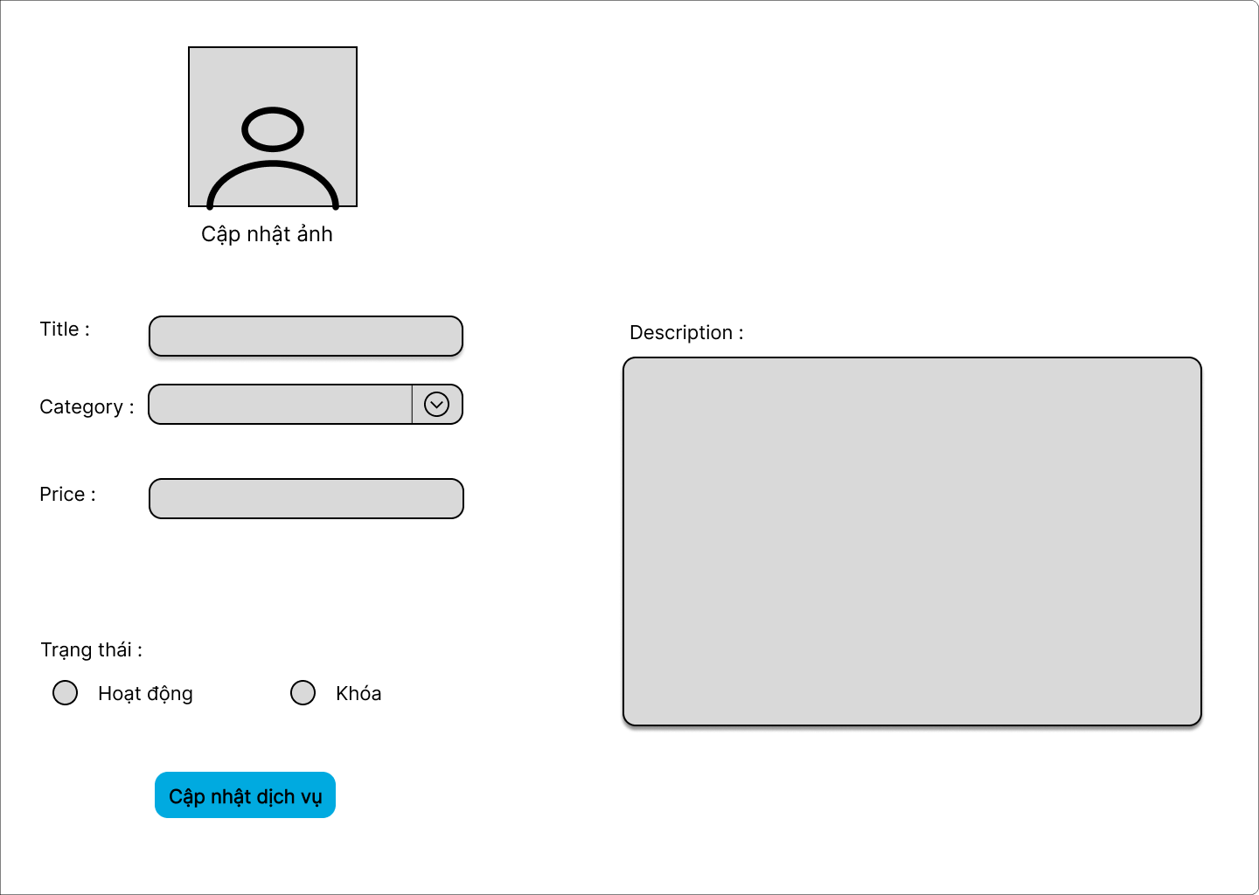

* **Function Details**:
* Data: Edit service information which include: images, title, category, price, description, status.
* Validate:
* When the user enters the text in the price will be displayed to enter the number.
* Business logics:
* When the user is to use the “cap nhat dich vu” button can edit patient information in it.
* Normal case:
* The administrator or person with permission to add the service enters the correct information of the new service. Adding the service is successful, and the information about the new service is stored in the database. The user receives a success message about adding the service.
* Abnormal case:
* When the user choose “Khoa”, this service won’t appear.
* When the user choose “Hoat dong”, this service will appear.
* When the user forgets to fill in the information in the fields, when pressing "save" the computer screen will show a message to fill in all the information in that field.

#### **e.Blog List**

**● *Function trigger:***

* Navigation Path:This function is triggered when the user clicks “Blog management” in navbar
* Frequency of Use : High.
* Priority: High.

**● *Function description:***

* Actor: Marketing
* Data processing:Get data from Blog table in database then list them on screen.

# Purpose :User view the paginated list of blogs.Display the all blog.

**● *Screen layout:*** Simulated prototype of the display, the sample below is for a all blog display.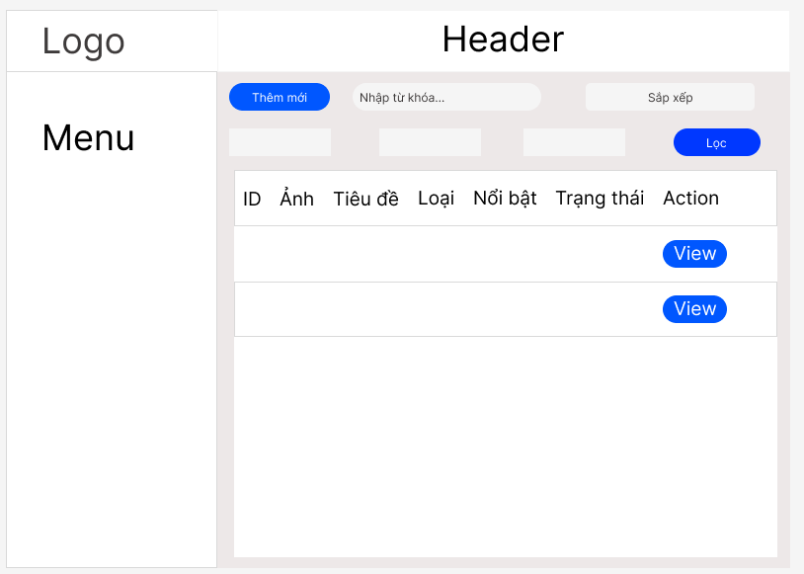

**● *Function Details:***

* Data: Blog updates include: name in category_blog table, name in users table and get all attributes in blog table .
* Validate:
* When the user enters the text in the price will be displayed to enter the number.
* Business logics:
* When the user is to use the “cap nhat dich vu” button can edit patient information in it.
* Normal case:
* Users access the blog management page by clicking "Manage Blog" in the navigation bar.
* Blog data is displayed as a paginated list, including title, image, category, and status.
* Abnormal case:
* failed database connection: In case the connection to the database fails, the system displays an error message and asks the user to try again later.
* Edit Error: In case of an error when the user tries to edit the blog information, the system will display an error message and not make the requested changes.

#### **f. Blog Detail**

**● *Function trigger:***

* Navigation Path:This function is triggered when the user clicks “View” in Blog management.
* Frequency of Use : High.
* Priority: High.

**● *Function description:***

* Actor: Marketing
* Data processing:Get data from Blog table in database and list them on screen and editable.

# Purpose :Users view the printed table of blogs to manage .Display the detail blog.

**● *Screen layout:*** Simulated prototype of the screen, the sample below is for the blog details screen.

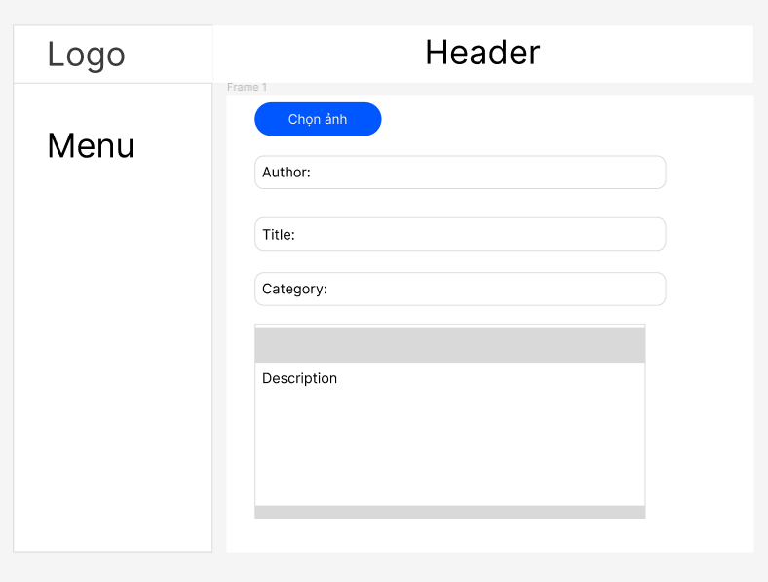

**● *Function Details:***

* Data: Get all attributes from category_blog . table .
* Business logics:
* When the user clicks "update" the information will be updated and printed on the table.
* Normal case:
* Select the photo on the camera to be updated and go to the Blog Management panel.
* The system retrieves data from the Blog table in the database.
* Abnormal case:
* Image upload error: If a user is having trouble uploading an image for the blog, such as an unsupported file format or file size limit exceeded.
* Database connection failed: In case the connection to the database fails, the system displays an error message and asks the user to try again later.

#### **j. Blog Add**

**● *Function trigger:*** Navigation Path:This function is triggered when the user clicks “Add new blog” in Blog management.

* Frequency of Use : High.
* Priority: High.

**● *Function description:***

* Actor: Marketing
* Data processing: Insert new information to the database (blog table) to display the newly added blog.

# Purpose :The user insert a new blog, updates the information the user enters into the database and prints the new blog added to the blog list page.

**● *Screen layout:*** Simulation prototype of the screen, the sample below is for the add new blog screen.

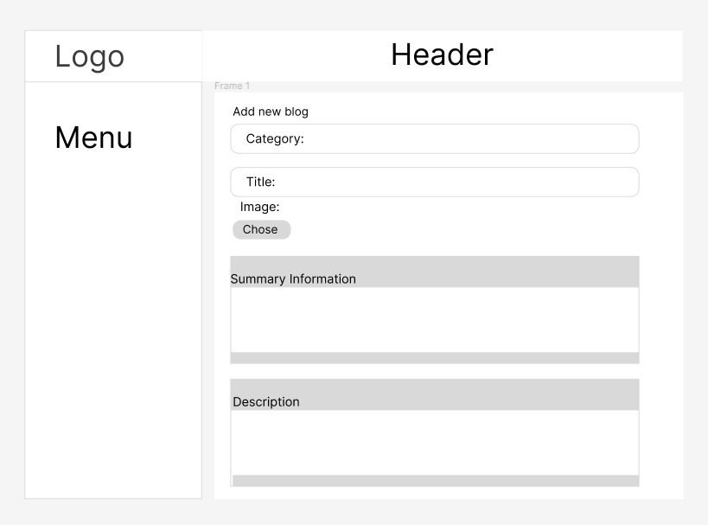

**● *Function Details:***

* Data: Insert new information to the blog table in database.
* Business logics:
* When the user clicks "Add new blog" the information will be updated to the database and then printed out in the blog management page and home page.
* Normal case:
* When the user inserts information, it is inserted to the database and displayed normally.
* The system inserts data from the Blog table in the database..
* Abnormal case:
* Image upload error: If a user is having trouble uploading an image for the blog, such as an unsupported file format or file size limit exceeded.
* Database connection failed: In case the database connection fails, the system cannot insert more information and displays an error message and asks the user to try again later.

#### **h. Blog Edit**

**● *Function trigger:***

Navigation Path:This function is triggered when the user clicks “Update blog” in view blog.

* Frequency of Use : High.
* Priority: High.

**● *Function description:***

* Actor: Marketing
* Data processing: Update information to the database in table blog to display the blog list page.

# Purpose :Let users edit the information of one or more blogs and print it to the screen in the "news" section of the home page.

**● *Screen layout:*** Simulated prototype of the screen, the sample below is for the blog edit screen.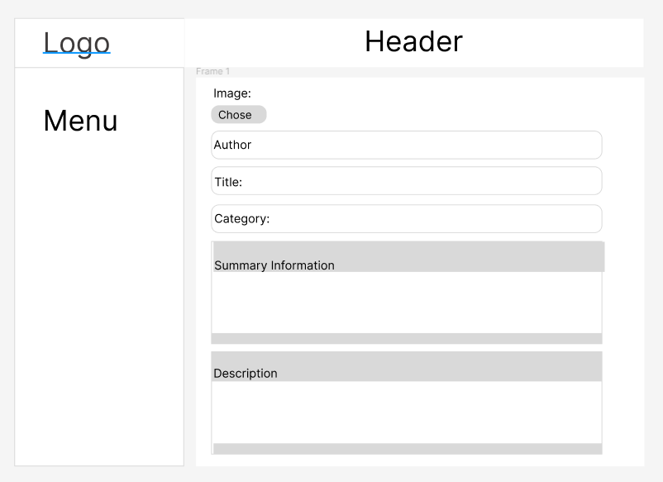

**● *Function Details:***

* Data: Update information to the blog table in database.
* Business logics:
* When the user clicks "View blog" the blog information will appear and the user can edit or do nothing.
* Normal case:
* When the user update information, it is updated to the database and displayed normally.
* The system update data from the Blog table in the database..
* Abnormal case:
* Image upload error: If a user is having trouble uploading an image for the blog, such as an unsupported file format or file size limit exceeded.

# **5. Staff Feature**

#### **a. Doctors List**

* ***Function trigger:***
* Navigation Path: When a user logs in as marketing, then click the avatar icon, then click “quan ly” page is automatically redirected here.
* Frequency of Use : High.
* Priority: High.
* ***Function description:***
* Actor: Staff.
* Purpose:
* Shown columns: Id, doctor name, gender, speciality, status.
* The user can search the doctors by name, filter them by gender & speciality.
* Data processing: Select doctor_id, doctor_name, status from doctor table and name from category_services table in database then list them on screen.
* ***Screen layout:*** simulated prototype of screen, below sample is for doctor list screen.

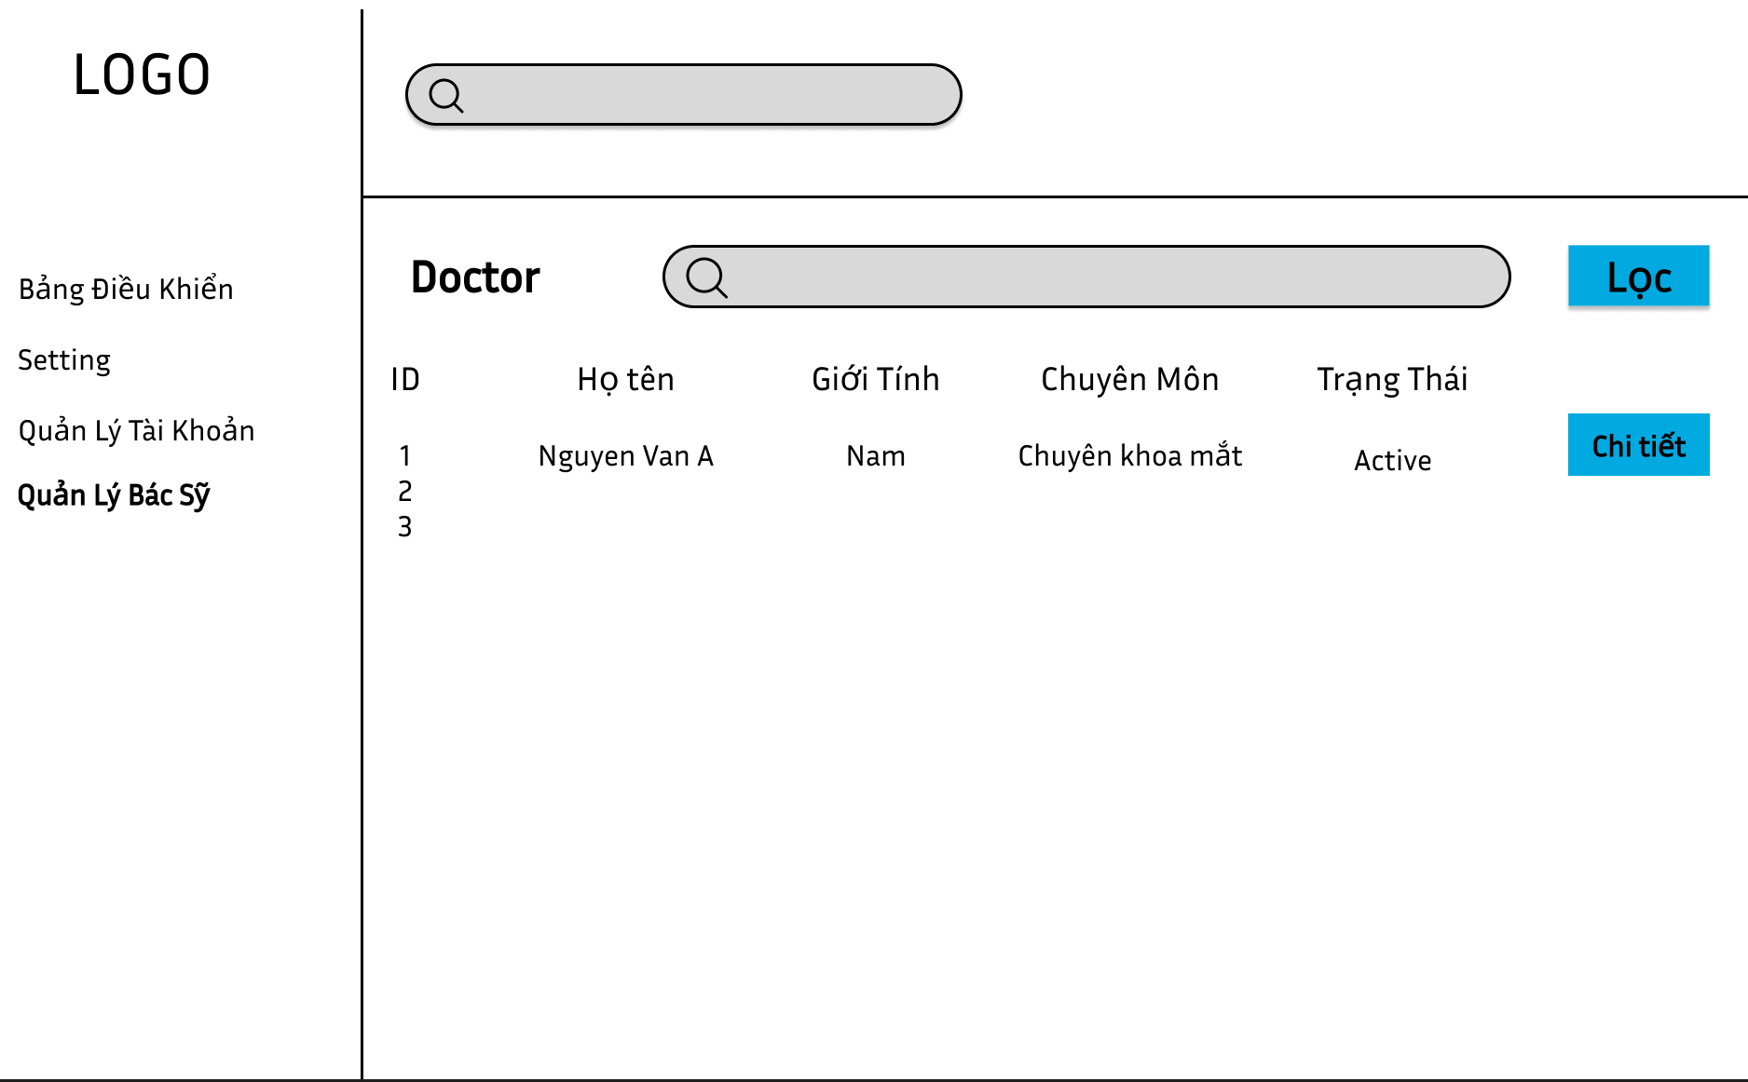

* ***Function Details:***
* Data: ID, Họ tên, Giới tính, Chuyên môn, Trạng thái.
* Business logics:
* The user can search the doctors by name, filter them by gender & speciality.
* The user can also choose to see full information when clicking“Chi tiet” of the doctor via the Doctor Detail screen".
* Normal case:
* If searching for a doctor's name, the screen will display that doctor's name searching for the words that the user searched for.
* Abnormal case:
* If you can't find the doctor's name whose name contains the user's search terms, the screen will not show the doctor.

#### **b.Doctor Details**

● ***Function trigger:***

* Navigation Path: This function is activated when the user clicks on “chi tiet” button.
* Frequency of Use : Low.
* Priority: Low.

●  ***Function description:***

* Actor: Staff.
* Purpose:
* The following information of the doctor is shown: name, Role, gender, DOB, Phone, Email, Status, Description.
* The user can also choose to edit the doctor information via the Doctor Edit screen.
* Data processing: Select doctor_id, doctor_name, gender, DOB, phone, email, status, description from doctor table name from category_services table in database then list them in screen.

● ***Screen layout:*** simulated prototype of screen, below sample is for doctor detail screen.

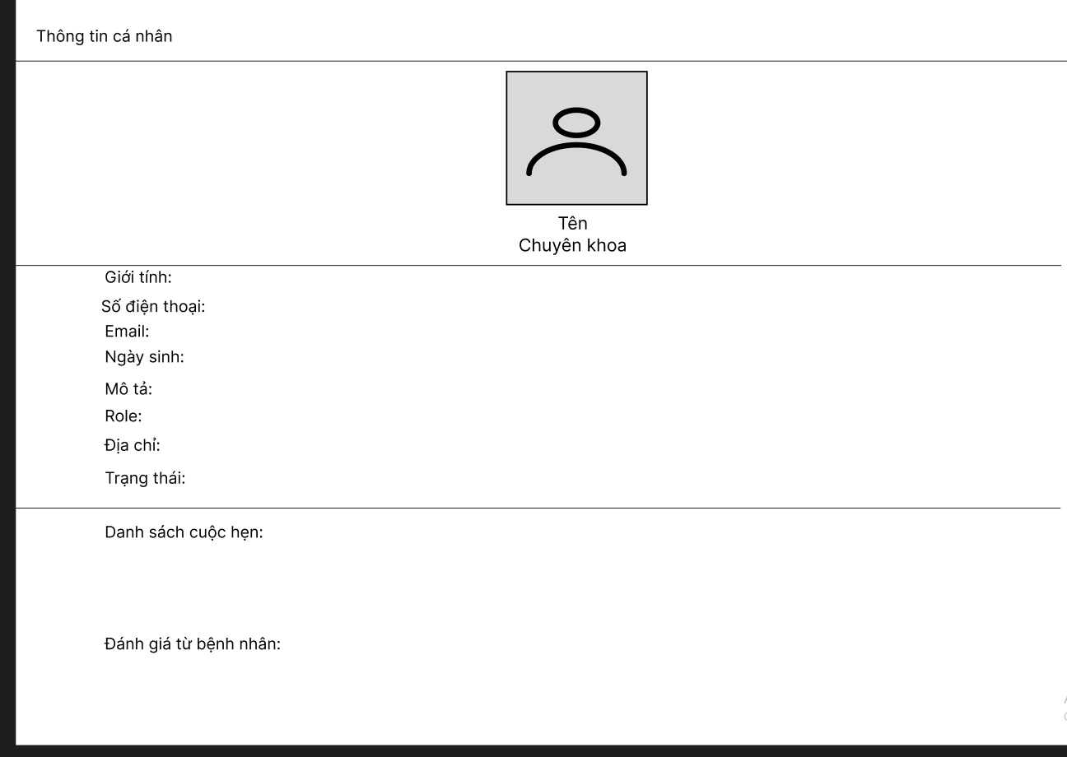

**●  *Function Details:***

* Data: The following information of the doctor is shown: name, Role, gender, DOB, Phone, Email, Status, Description
* Business logics:
* From this screen, the user can also activate or deactivate a doctor + view his/her appointments + view feedbacks (both rate & comments) about him/her
* The user can also choose to edit the doctor information via the Doctor Edit screen"

#### **c.Doctor Edit**

***● Function trigger:***

* Navigation Path: This function is activated when the user clicks button edit.
* Frequency of Use : Low.
* Priority: Low.

***● Function description:***

* Actor: Staff.
* Purpose: Edit doctor information which include: name, gender, DOB, Phone, doctor role, speciality, description.
* Data processing: When user input doctor information: doctor_id, doctor_name, gender, DOB, phone, email, status, description then this data will send and update this in database.

***● Screen layout:*** Simulated prototype of screen, below sample is for doctor edit screen.

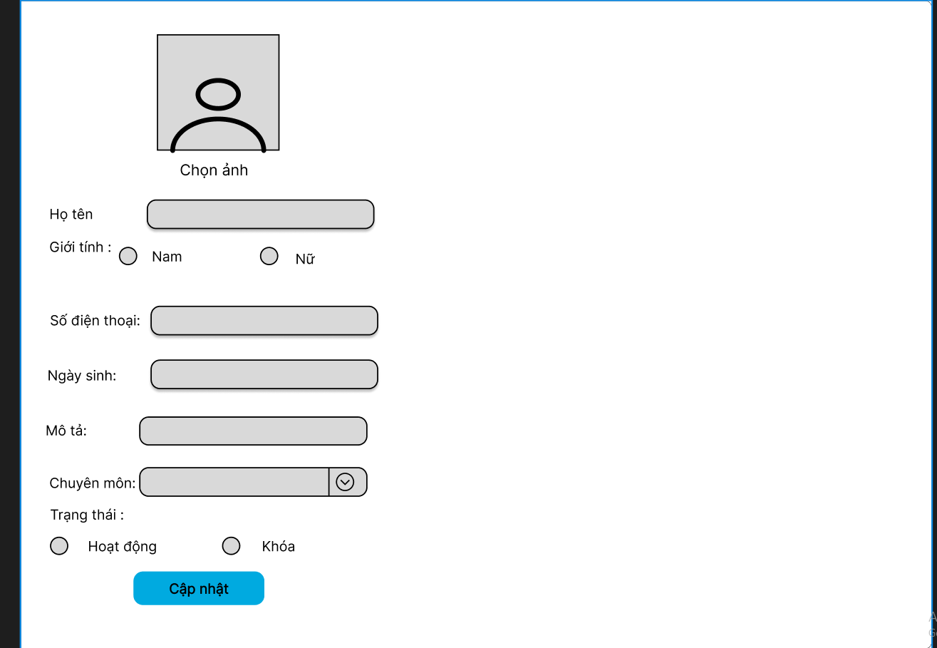

● ***Function Details*:**

* Data: name, gender, DOB, Phone, doctor role, speciality, description.
* Validate:
* When the user enters the text in the phone number will be displayed to enter the number.
* When the user enters the wrong format in the email, a message will be displayed asking to re-enter the correct email format.
* When the user enters the wrong format in the DOB (date), a message will be displayed asking to re-enter the correct DOB (date) format.
* Business logics:

+ When the user is to the use of the “save” button can edit patient information in it and appear the notification.

* Normal case:
* The administrator or person with editing rights enters the correct information of the doctor, including name, specialty, address, phone number, email, title. The information editing process is successful, and the new. information is updated in the database. The user receives a successful message about editing the doctor's information.
* Abnormal case:
* When the user choose “Khoa”, this service won’t appear.
* When the user choose “Hoat dong”, this service will appear.
* When the user forgets to fill in the information in the fields, when pressing "save" the computer screen will show a message to fill in all the information in that field.

#### **d.Patients List**

● ***Function trigger:***

* Navigation Path: This function is activated when the user clicks on button Patient List.
* Frequency of Use : High.
* Priority: High.

● ***Function description:***

* Actor: Staff.
* Purpose: List of patients in the system (search by name) with following columns: Id, patient name, gender, date of birth, and status.
* Data processing: Select patient_id, patient_name, gender, DOB, status from Patient table in database then list them in screen.

●  ***Screen layout:*** Simulated prototype of screen, below sample is for list patients screen.

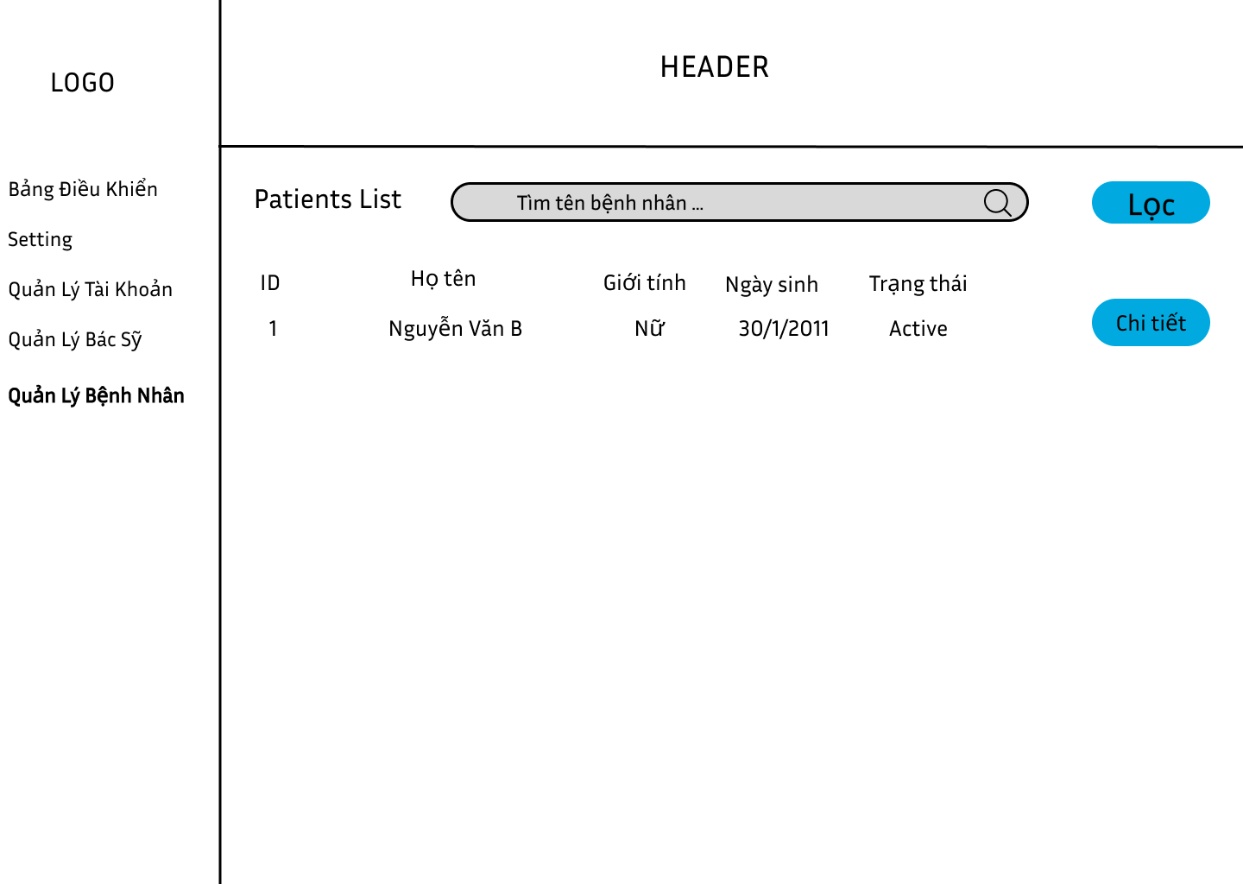

* ***Function Details*:**
* Data: Shown columns: Id, patient name, gender, date of birth, status.
* Business logics :
* Search by name when clicking “Loc” with following columns: Id, patient name, gender, date of birth, and status.
* The user can also choose to see full information when clicking “Chi tiet” of the patient via the Patients Detail screen".
* Normal case:
* If searching for a patient's name, the screen will display that patient's name searching for the words that the user searched for.
* Abnormal case:
* If you can't find the patient's name whose name contains the user's search terms, the screen will not show the patient list.

#### **e.Patient Details**

* ***Function trigger:***
* Navigation Path: This function is activated when the user clicks on manage 1 button “chi tiết”**.**
* Frequency of Use : High.
* Priority: High.
* ***Function description:***
* Actor: Staff.
* Data processing: Select username, patient_id, gender, phone, email, DOB, address, status from patient database in database and list them in website.
* Purpose: View details of a specific patient (chosen from the Patients List screen), from this screen:
* The user can see the avatar, full name, email, gender, DOB, phone, email,status. The user can activate or deactivate a patient.
* The user can also choose to edit the patient information via the Patient Edit screen.
* ***Screen layout:*** simulated prototype of screen, below sample is for admin patients screen.

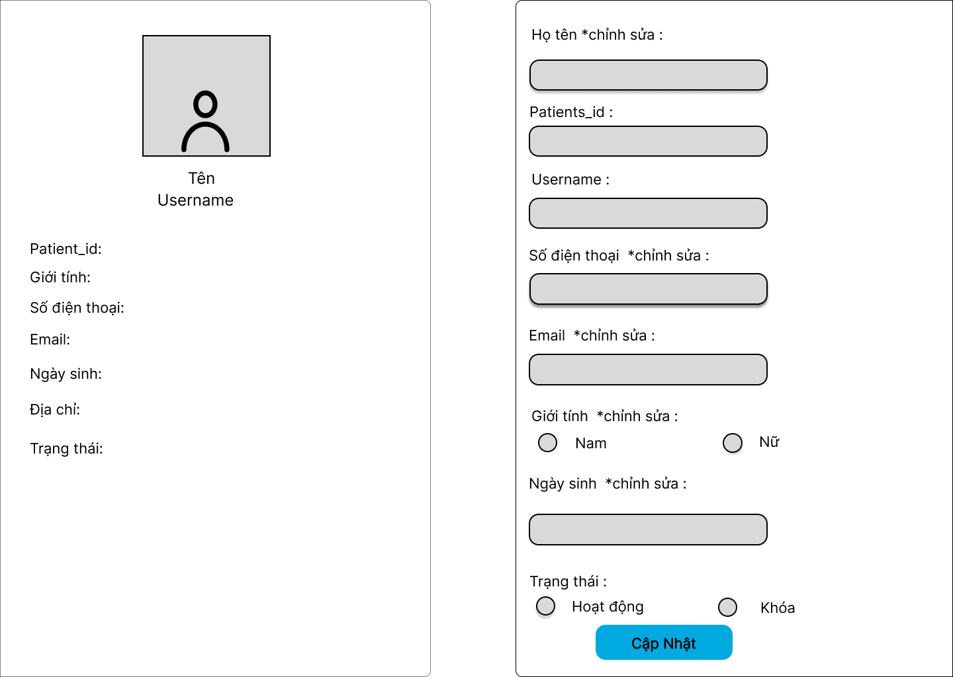

* ***Function Details***:

- Purpose: The user can see the avatar, full name, email, gender, DOB, phone, email,status.

- Business logics:

* when user enters Patients user can see information them
* The user can also choose to edit the patient information via the Patient Edit screen in the right screen.

#### **f.Patient Edits**

**● *Function trigger:***

* Navigation Path: Function works when user edit info in edit info box and press cập nhật button.
* Frequency of Use : Low.
* Priority: Low.

**● *Function description:***

* Actor: Staff.
* Data processing: Update username, patient_id, gender, phone, email, DOB, address, status from patient table in database and list them in website.
* Purpose: Edit Patient information, including name, patients_id, gender, DOB, phone, address, status.

**● *Screen layout:*** Simulated prototype of screen, below sample is for admin Patients screen.



* ***Function Details:***
* Data: Edit information include: Họ tên, số điện thoại, email, giới tính, ngày sinh, trạng thái.
* Validate:
* When the user enters the text in the phone number will be displayed to enter the number.
* When the user enters the wrong format in the email, a message will be displayed asking to re-enter the correct email format.
* When the user enters the wrong format in the DOB (date), a message will be displayed asking to re-enter the correct DOB (date) format.
* Business logics:
* When the user is to the use of the “cập nhật” button can edit patient information in it.
* Edit Patient information, including name, patients_id, gender, DOB, phone, address, status.
* Normal case:
* The administrator or person with editing rights enters the correct patient information. The information editing process is successful, and the new information is updated in the database. The user receives a successful message about editing patient information.
* Abnormal case:
* When the user choose “Khoa”, this service won’t appear.
* When the user choose “Hoat dong”, this service will appear.
* When the user forgets to fill in the information in the fields, when pressing "save" the computer screen will show a message to fill in all the information in that field.

#### **g.Appointments List**

* **Function trigger:**
* Navigation Path: This function is triggered when the user clicks to “Quản lý lịch hẹn”
* Frequency of Use : High.
* Priority: High.
* **Function description**
* Actor: Staff
* Purpose:
* Shown columns:Id, Patient Name, Doctor Name, Time, Status
* staff can view all appointments
* Data processing
* Select doctor_id, patient _id, status from "doctor" table, "patient" table and "appointments" table in database
* **Screen layout:** mock-up prototype of the screen, sample below is for the appointment list screen

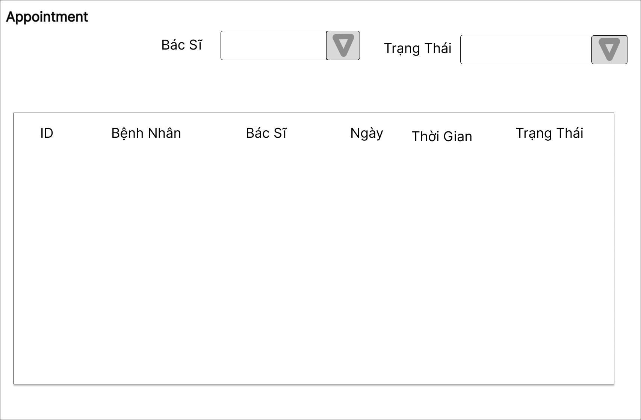

**\* Function details:**

* Data: Shown columns:Id, Patient Name, Doctor Name, Time, Status
* Business logics:
* View the list of appointments in the system including columns: Id, Patient Name, Doctor Name, Time, Status. From here, staff can filter the list by doctor's name, filter by status
* staff can view all appointments
* Normal case:
* Staff can search for a doctor by name or by status, when the search is successful, the screen will display the doctor's information.
* Abnormal case:
* When the administrator searches for a doctor by name that is incorrect or not in the system, the screen will display an empty list.

#### **h. Reserve a Service**

* **Function trigger:**
* Navigation path: This function is triggered when the user clicks to “chi tiết”.
* Frequency of Use : High.
* Priority: High.
* **Function description:**
* Actor: Staff
* Purpose:
* Shown properties:avatar, name, mobile, gender, date of birth,avatar, name, mobile, gender, speciality,date, time, status, description, in-charged staff.
* Data processing
* Data processing: Select patient _id, doctor_id, from doctor table and from patient table in database and list on screen.
* **Screen layout**: mock-up prototype of the screen, sample below is for the appointment details screen

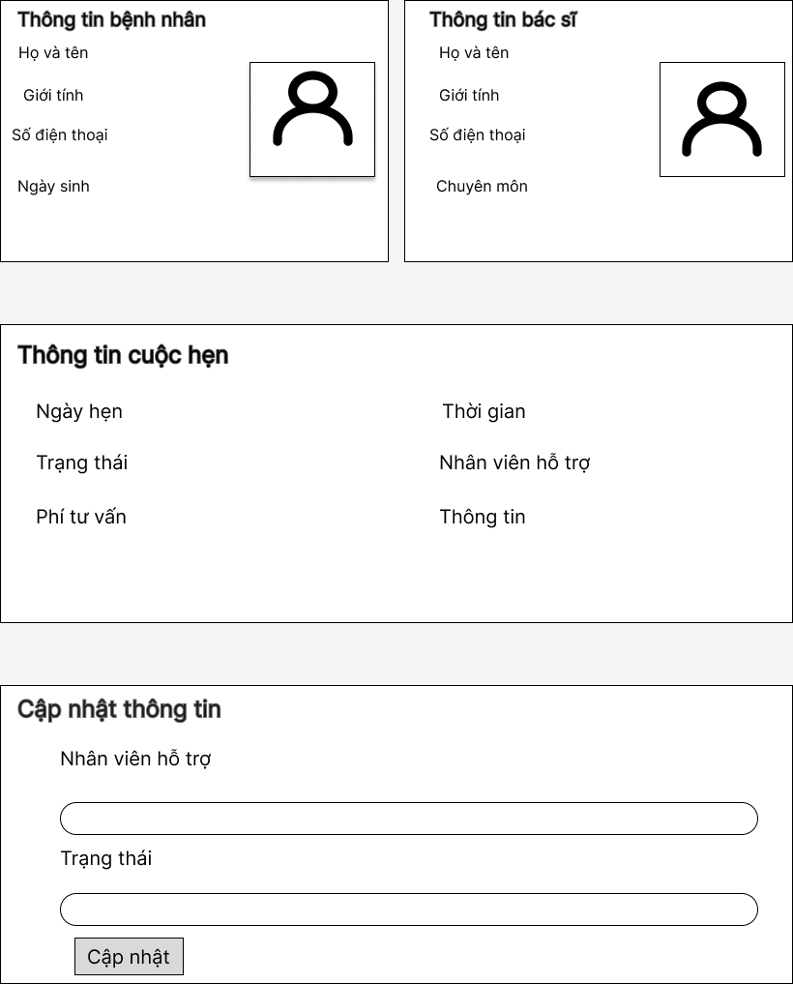

**● Function details:**

* Data: Shown properties:avatar, name, mobile, gender, date of birth,avatar, name, mobile, gender, speciality,date, time, status, description, in-charged staff.
* Business logics**:**
* View details of a specific appointment (chosen from the Appointments list) which include:
* Patent information: avatar, name, mobile, gender, date of birth
* Doctor information: avatar, name, mobile, gender, speciality.
* Appointment information: date, time, status, description, in-charged staff.
* On this screen, user can input/edit the consulting fee and change appointment status from Pending to Assigned or Canceled ; the admin can change the in-charged staff to a specific staff.
* Normal case**:**
* Displays detailed information of patients and doctors who have been booked
* Admin successfully changed staff in charge
* Abnormal case**:**
* When the administrator clicks on the item "support staff" in the "update information" section and the administrator enters the employee's name as a number or the employees are not in the system, the update will fail. is "update failed"

#### **i. Reservations List**

* **Function trigger:**
* This function is triggered when the user clicks to “Quản lý dịch vụ”
* Frequency of Use : High.
* Priority: High.
* **Function description:**
* Actor: Staff
* Purpose:
* Shown columns:: Id, patient name, service name, time, status
* Staff can see all the service
* Data processing
* Select doctor_id, service_id, status from "doctor", "doctor_service" table and "appointments" table in database.

* **Screen layout:** mock-up prototype of the screen, sample below is for the reservations list screen

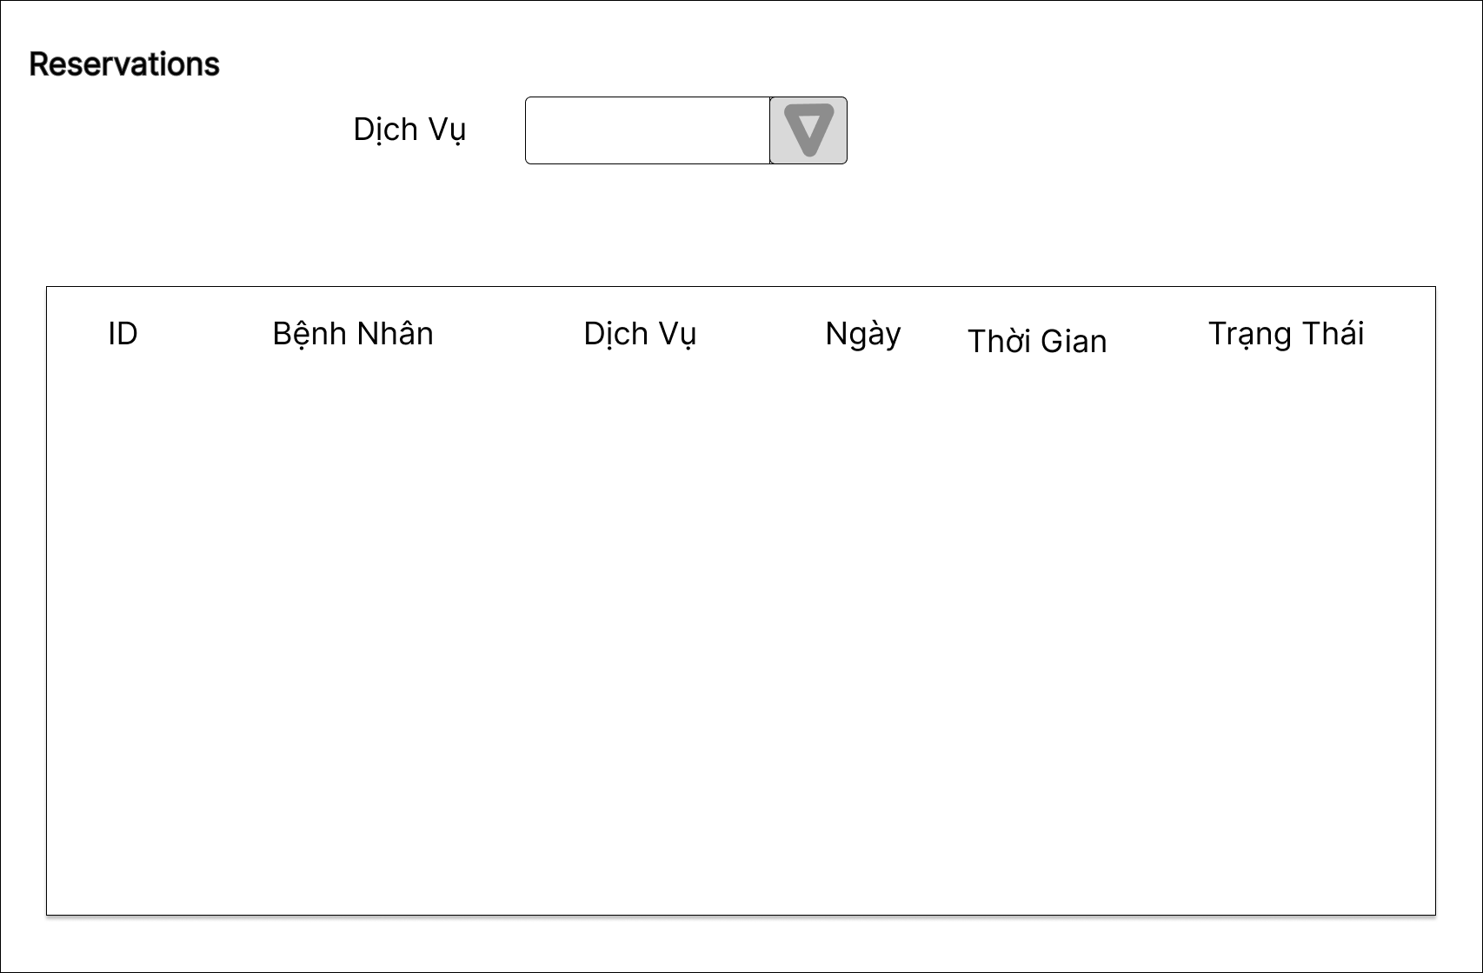

* **Function details:**
* Data: Shown columns:: Id, patient name, service name, time, status
* Business logics:
* **V**iew list of reservations in the system, which include following columns: Id, patient name, service name, time, status; From this, staff can filter the list by the service name
* Staff can see all the service
* Normal case:
* Staff can search by service name or by status, when the search is successful, the screen will display the service being searched.
* Abnormal case**:**
* When a Staff searches for a service by name but the name is wrong or not in the system, the screen will show an empty list.

# **6. Doctor Feature**

#### **a.Patient List**

**●** ***Function trigger:***

* Navigation Path: This function is triggered when the user clicks to “ Patients List”.
* Frequency of Use : High.
* Priority: High.

**● *Function description***:

* Actor:Doctor
* Data processing: The data to print to the table needs name, phone, email from the users table, date in the appointments table, dob from the patient table.
* Purpose:
* Display columns Patient, date booking, phone. email, dob, "detail".
* Information of any patient who makes an appointment will be processed and stored by the system and displayed data through a table.
* View patient details in the "Detail" button.

**●** ***Screen layout***:The screen below depicts the prototype of this function.

**●** ***Function details***:

* Data: The variables shown in the table are patient_id, name, date, phone, email, dob, detail.
* Business logics:
* Physicians can search filtered by patient name, phone number, date, and email.
* The doctor can see the patient details, when clicking "detail" in the last column.
* Normal case: If searching for a patient, the patient name entered in the search bar will be displayed.
* Abnormal case: When entering on the search bar for patients whose name is not in the list, the table will display "Patient name does not exist".

#### **b. My Patient Details**

**●** ***Function trigger***:

* Navigation Path: This function is triggered when the user clicks to “Detail”.
* Frequency of Use : High.
* Priority: High.

**● *Function description*:**

* Actor: Doctor
* Data processing: The data to print out the table needs date of birth, gender, address, phone from the users table, and blood group in the appointments table.
* Purpose :
* Show detailed information of the doctor's patient along with the list of appointments with him/her.
* List of patient's completed appointments, displayed including scheduled and future appointments.

**●** ***Screen layout***: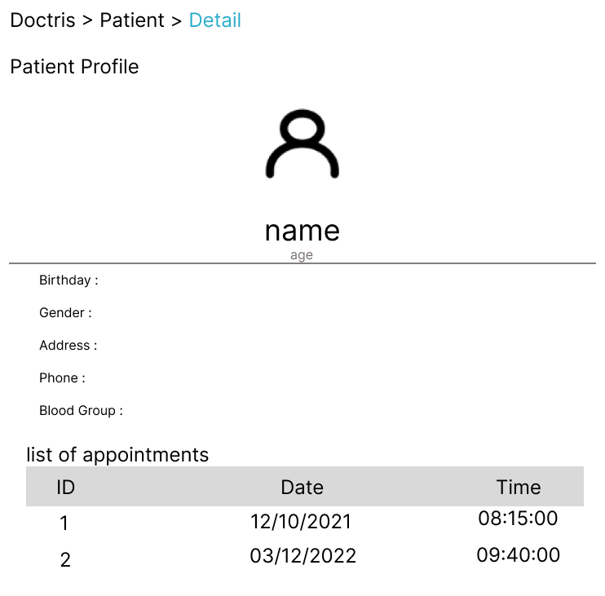

**●** ***Function details***:

* Data: The variables in the table are birth, gender, address, phone, blood.
* Business logics:
* View detailed information of the doctor's patient (name, email, mobile, gender, date of birth) along with the list of appointments with him/her.
* Can “edit” date of birth, gender, address and phone number.
* Normal case: Doctors can only view patient information.

#### **c. Appointment List**

**●** ***Function trigger***:

* Navigation Path: Function trigger: This function is triggered when the user clicks to “My Appointments”.
* Frequency of Use : High.
* Priority: High.

**● *Function description***:

* Actor: Doctor
* Data processing: The data to print out the table needs id, name, age, gender, date, time from the appointments table.
* Purpose:
* Show list of doctor's appointments.
* When the doctor clicks on "appointment" the data of the appointments will appear in tabular form.
* Search for an appointment in the list.

**●** ***Screen layout*:** 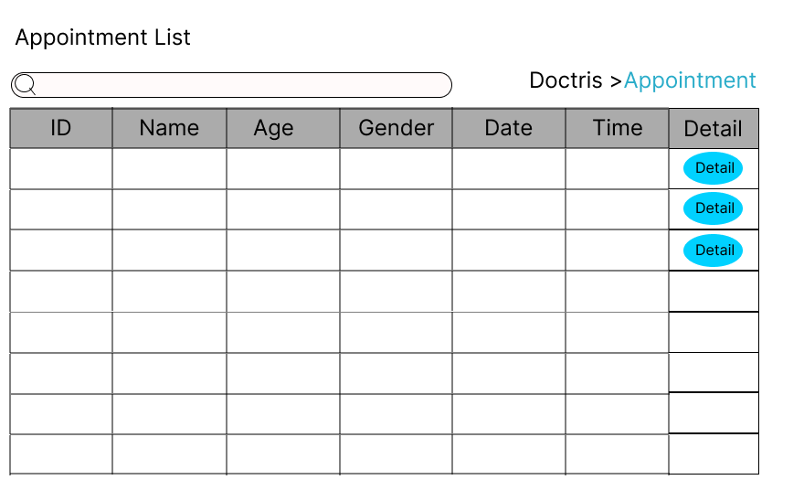

**●** ***Function details*:**

* Data:The variables used in the table are id, name, age, gender, date, time, detail.
* Business logics:
* View doctor's list of assigned appointments paginated which includes the following column: Id, patient name, patient Id, appointment date/time, Status.
* From this screen, the user can choose to view detailed information of the appointment (via the My Appointment Details page).
* The data is shorted by the appointment date/time (the latest one is on the top).
* When clicking "detail" user can redirect to the “Appointment detail” page.
* Normal case: Appointments can be searched by patient name, date or time.
* Abnormal case:

#### **d. Appointment Detail**

**●** ***Function trigger*:**

* Navigation Path: Function trigger: This function is triggered when the user clicks to “Detail”.
* Frequency of Use : High.
* Priority: High.

**● *Function description*:**

* Actor: Doctor
* Data processing: The data to print out the table needs name, gender from the users table, time, date, apartment in the appointments table.
* Purpose:
* Show detailed information of a single Appointment.
* Display the details screen of an appointment, include: Patient’s name, age, time, date, gender, fees,...
* Doctors can edit patient information.

**●** ***Screen layout*:***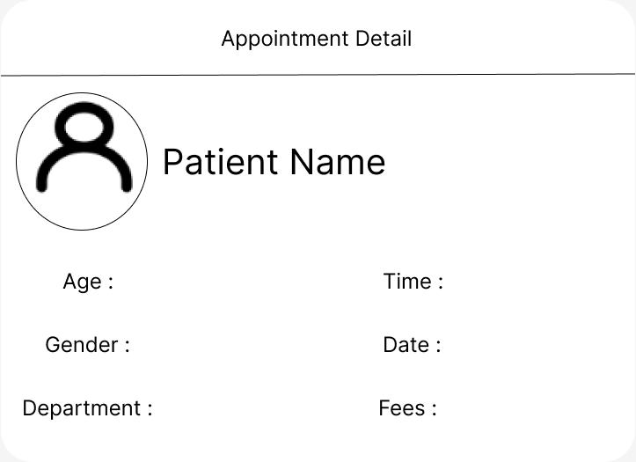*

**●** *Function details*:

* Data: Variables used in the table are name, age, date, time, depart.
* Business logics:
* View detailed information of the appointment. On this form, the doctor is allowed to change the appointment status from Assigned to Completed.
* Normal case: The doctor can only view information about the patient.

# **7. Patient Feature**

#### **a. Book an Appointment**

**●** ***Function trigger*:**

* Navigation Path: This function is triggered when the user clicks to “Doctor” on headmenu of the home page , they can choose the doctor that they want then click to “Make an appointment”.
* Frequency of Use : High.
* Priority: High.

**● *Function description*:**

* Actor: Patient
* Data processing: The data to print out the table needs name, email, phone in the users table, department, doctor in the doctor table, date, time in the appointments table.
* Purpose:
* Patients can book appointments with a doctor and date time that they want.
* Displays information for users to fill in or select.
* when the user selects a doctor by clicking the down arrow. If any doctor is full, the system will not show that doctor, if all doctors are full, it will notify the user.
* If the user enters a date and time that does not exist, the system will give an error.

**●** ***Screen layout*:***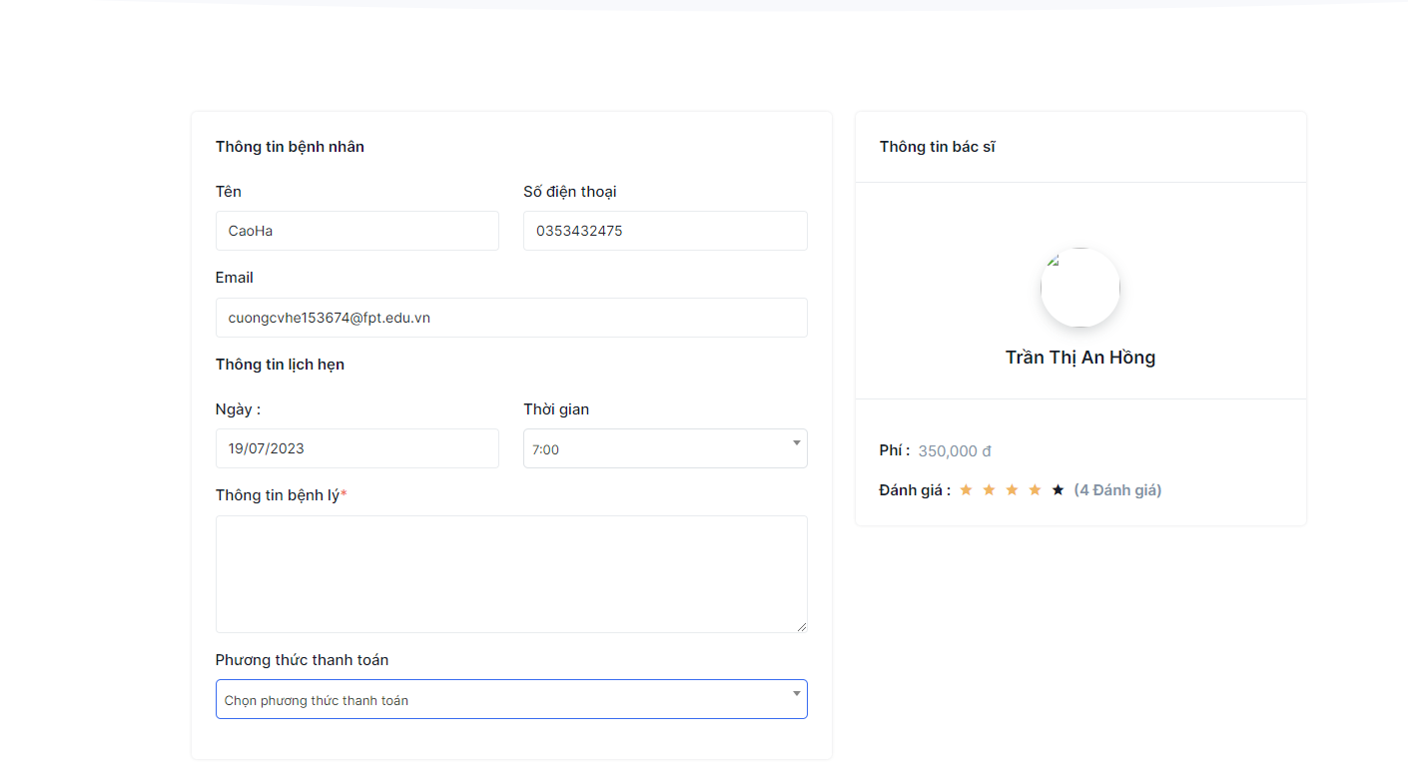*

**●** ***Function details*:**

* Data: The variables used are, name, email, doctor, date time, phone, des.
* Validation:
* Patient name must be capitalized, email must be in the format x@gmail.com.
* Department and doctor are selected by the system.
* Date, time requires the user to enter the correct date format and does not enter a date in the past.
* Phone number no more than 11 numbers
* The description is free for users to fill in.
* Business logics:
* Current information (name, email, phone),The to-be-booked doctor information (avatar, name, rated star, number of feedbacks). Input the booking details (date, time, description)
* The newly booked appointment would be assigned automatically to the staff who has been assigned appointment or reservation for the longest time
* when the user clicks on "booking an appointment" there will be a message that the registration is successful.
* Normal case: User clicks on "booking an appointment" button and successful registration will display a message.
* Abnormal case: User registration failed when entering incorrect information, the system will notify.

#### **b. Appointment history**

**●  *Function trigger*:**

* Navigation Path: This function is triggered when the user clicks to “booking history”.
* Frequency of Use : High.
* Priority: High.

**● *Function description***:

* Actor: Patient
* Data processing: The data to print out the table needs date, time from appointment, doctor, specialist table in doctor table.
* Purpose:
* Patients can view history appointments.
* Display the doctor's name, their specialty, date/time and the status of the appointment.
* The system will save the placed calendars in the personal information for the patient.
* The data will be displayed in a tabular format for the user to see the list of old appointments

**●** ***Screen layout:*** simulated prototype of screen, below sample is for appointments history screen.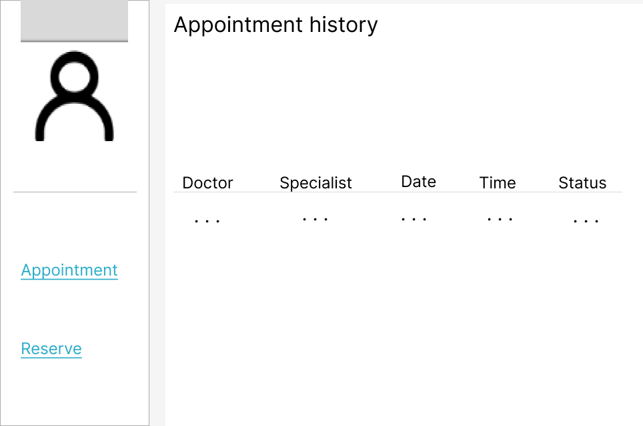

**●** ***Function details:***

* Data: The variables used are doctor, specialist, date, time, status.
* Business logics:
* When you click on "appointment history", the user's list of booked appointments is paginated which includes the following column: Id, doctor avatar, doctor name, doctor Id, appointment date/time, status.
* The data is shortened by the appointment date/time (the latest one is on the top).
* Normal case: User can see the list of appointment history, if an appointment exists, it will be displayed on the screen.
* Abnormal case: If the user has not booked an appointment, it will show on the screen that there are no appointments available.

#### **c. Reserve a service**

**●  *Function trigger:***

* Navigation Path: This function is triggered when the user clicks to “Services” on the head menu of the home page , they can choose the doctor that they want then click to “Schedule”.
* Frequency of Use : High.
* Priority: High.

**● *Function description:***

* Actor: patient
* Data processing: The data to print out the table needs name, email, phone in the users table, department, doctor in the doctor table, date, time in the appointments table.
* Purpose:
* Patients can reserve a service and date time that they want.
* Displays on the screen bars for filling in information, and there are columns that force the user to be selected only and cannot be filled in. For example: Department, doctor, ..

**●** ***Screen layout:*** Simulated prototype of screen, below sample is for Reserve a Service screen.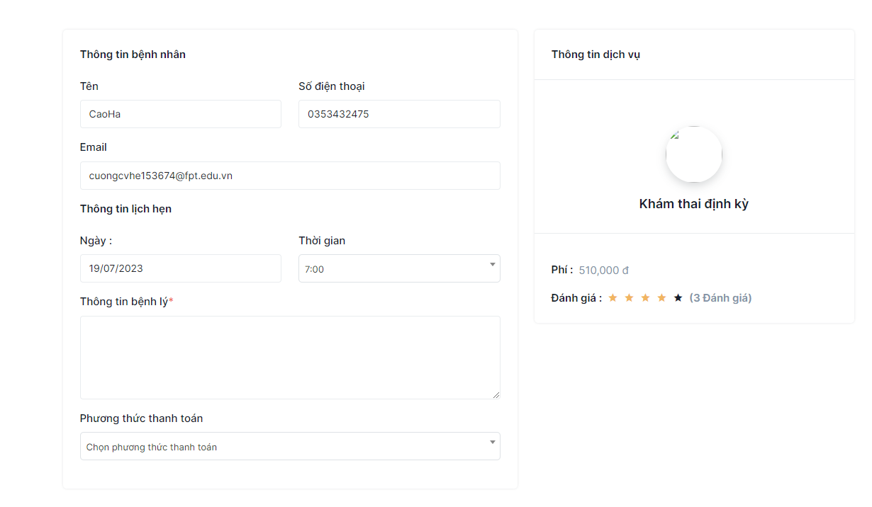

**● *Function details:***

* Data: The variables used are, name, email, doctor, date time, phone, des.
* Validation:
* Patient name must be capitalized, email must be in the format x@gmail.com.
* Department and doctor are selected by the system.
* Date, time requires the user to enter the correct date format and does not enter a date in the past.
* Phone number no more than 11 numbers
* The description is free for users to fill in.
* Business logics:
* Their current information (name, email, phone).
* Input the booking details (date, time, description).
* Choose a doctor or department,....
* Users who click on "Booking an appointment" in the reservation page will have a successful booking notification notifying them.
* Normal case: User clicks on "booking an appointment" button and successful registration will display a message.
* Abnormal case: User registration failed when entering incorrect information, the system will notify.

#### **d. Reserve a Service history**

**●  *Function trigger*:**

* Navigation Path: This function is triggered when the user clicks to “service history”
* Frequency of Use : High.
* Priority: High.

**● *Function description*:**

* Actor: patient
* Data processing: The data to print out the table needs date, time from appointment, specialist table in doctor table.
* Purpose:
* Patients can view history reservations.
* Here displays columns like: appointment, date, time, pay, status,...
* The system will save the placed calendars in the personal information for the patient.
* The data will be displayed in a tabular format for the user to see the list of old appointments

**●** ***Screen layout:*** Simulated prototype of screen, below sample is for Reservation history screen. 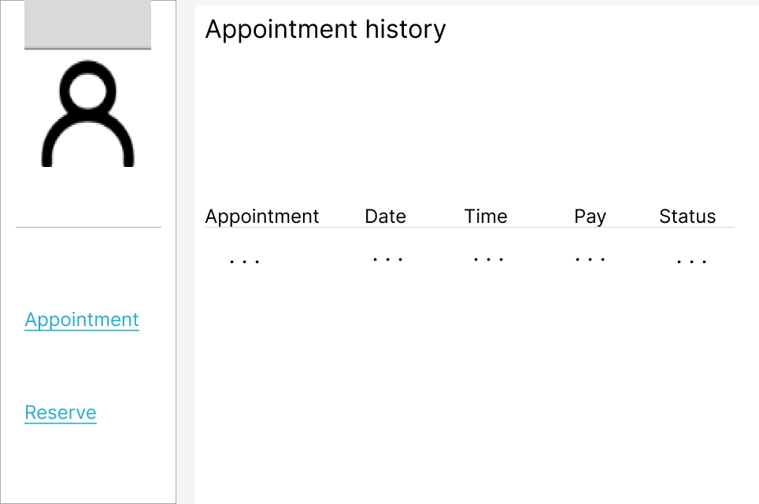

**●** ***Function Details:***

* Data: The variables used are appointment, date, time, pay, status.
* Business logics:
* when the user clicks on the "Reserve" mountain, the list of booked appointments will be displayed to view the list of reservations of the user.
* Include following columns: appointment, service name, service date/time, price, status
* From the screen the user can choose between "appointment" and "reserve"
* Normal case: User can see the list of appointment history, if an appointment exists, it will be displayed on the screen.
* Abnormal case: If the user has not booked an appointment, it will show on the screen that there are no appointments available.